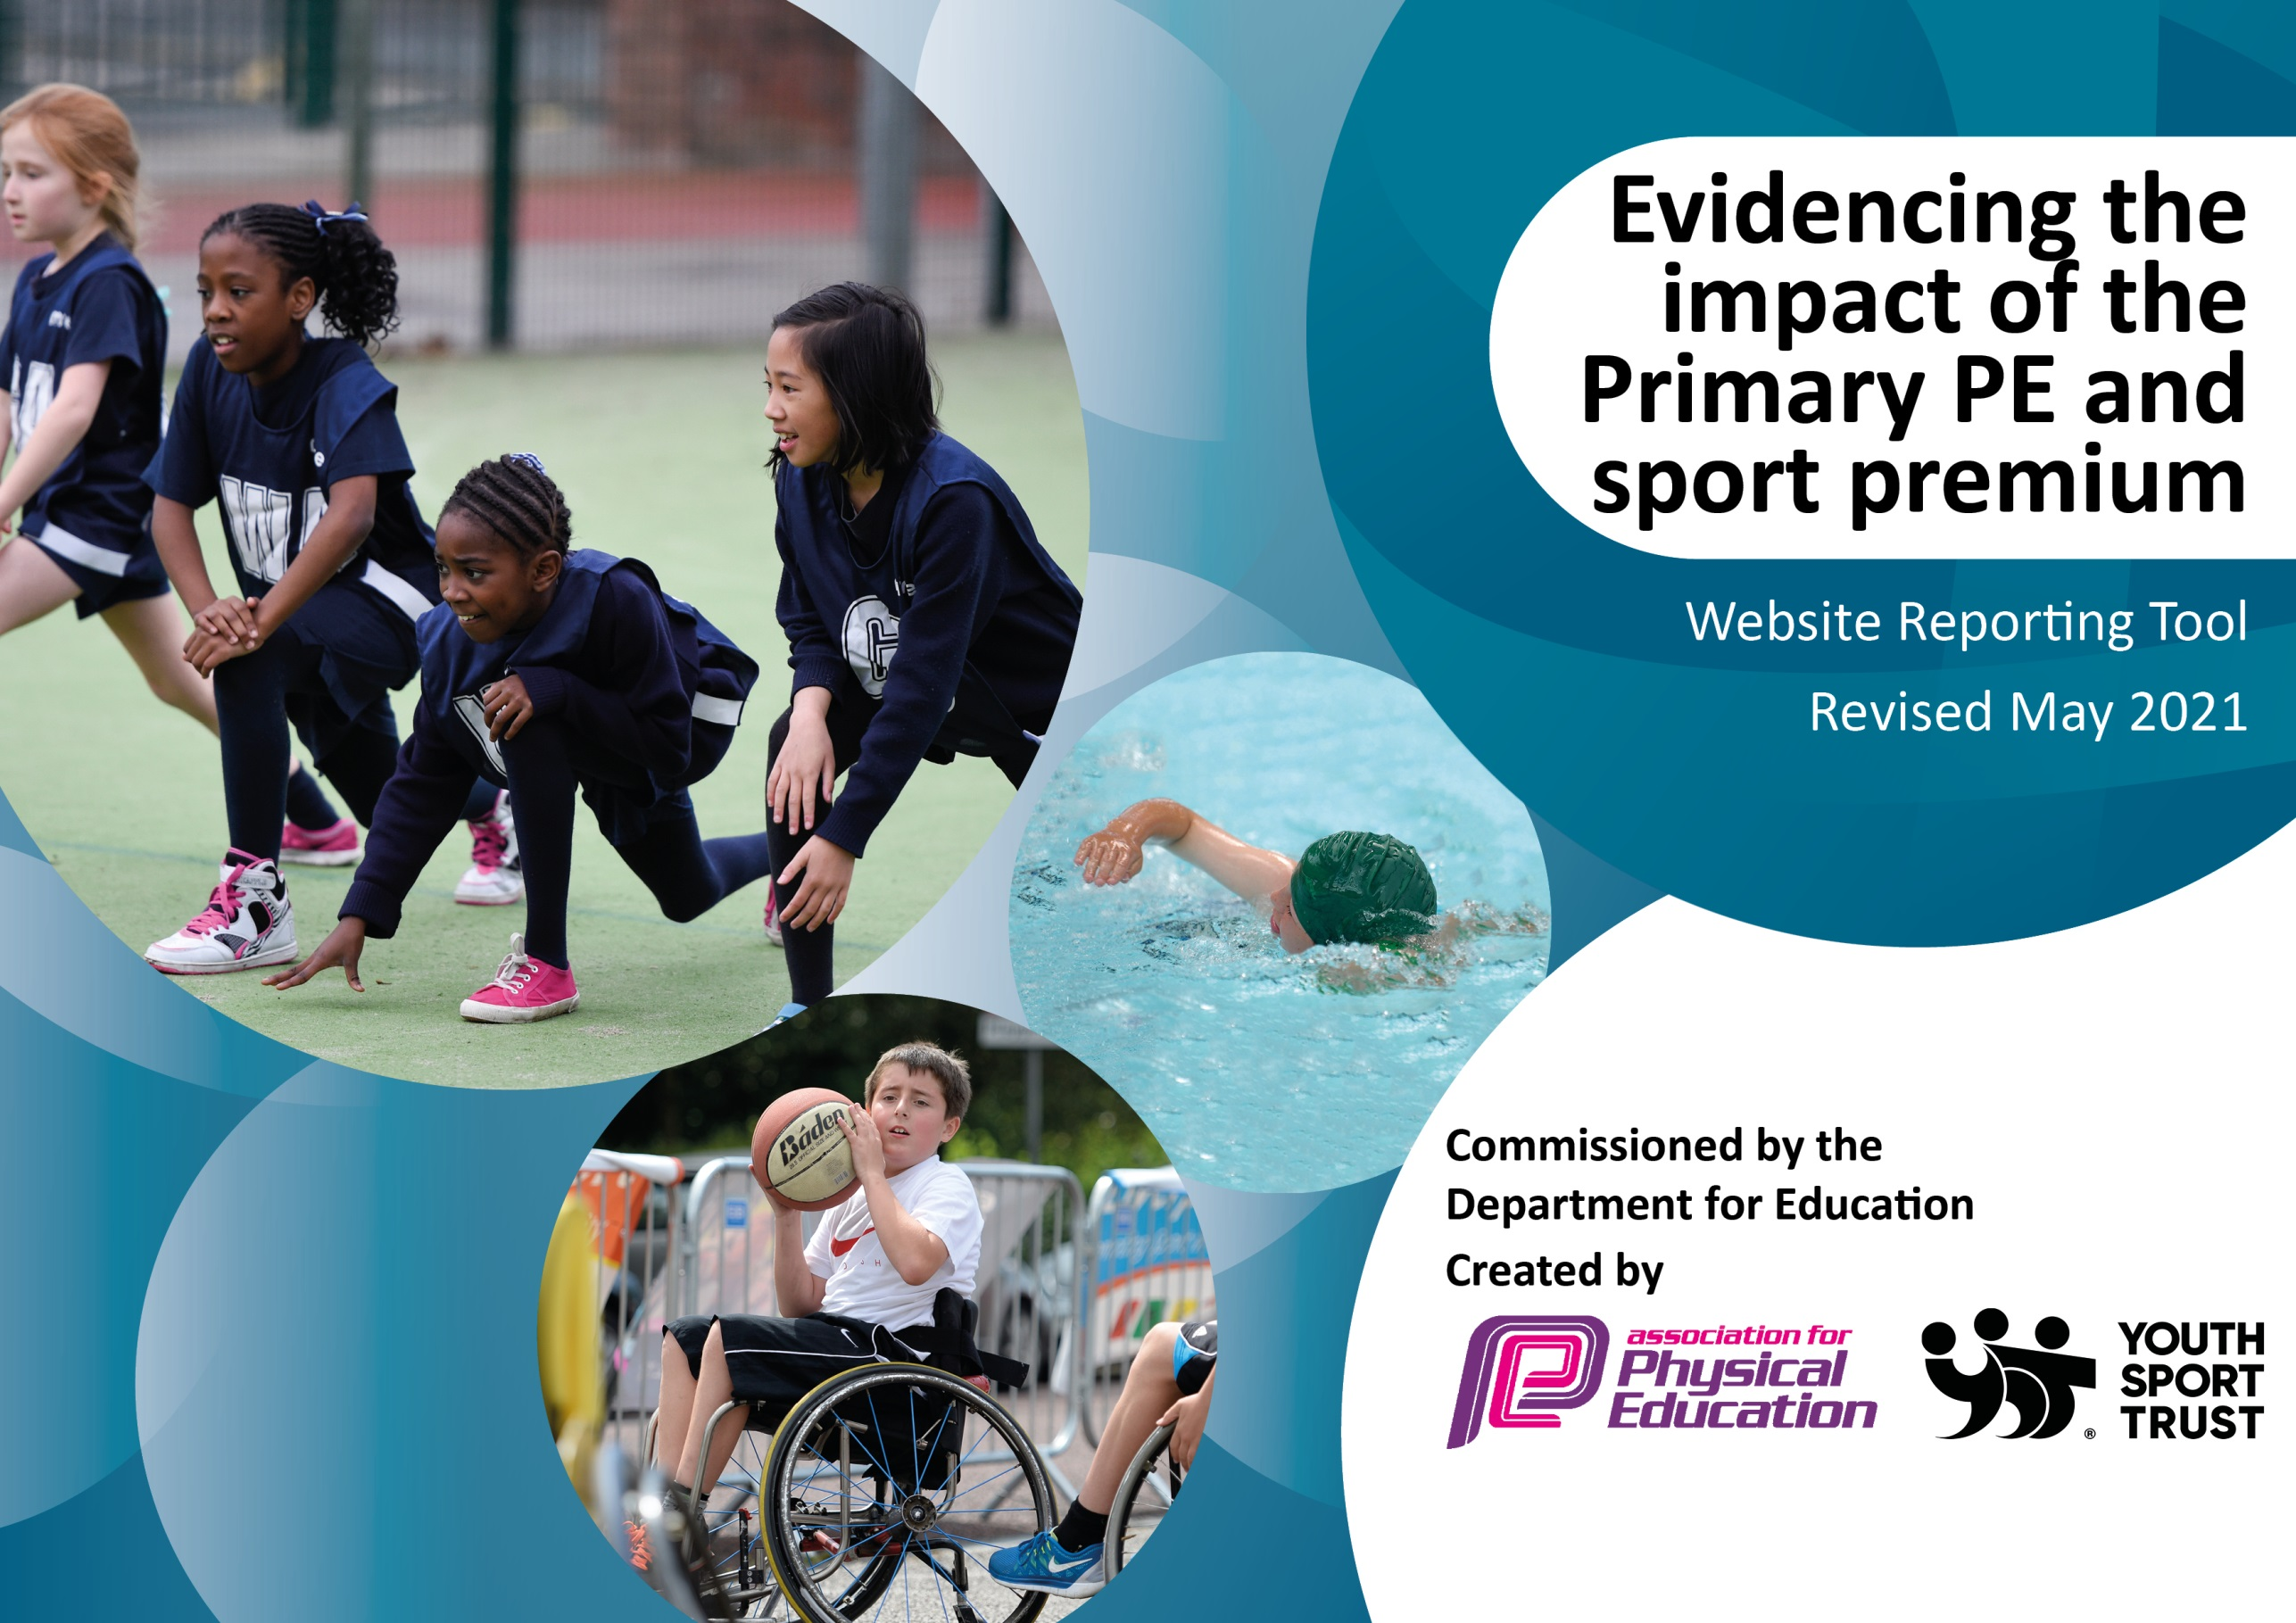

It is important that your grant is used effectively and based on school need. The Education Inspection Framework (Ofsted 2019 p64) makes clear there will be a focus on ‘whether leaders and those responsible for governors all understand their respective roles and perform these in a way that enhances the effectiveness of the school’.

Under the Quality of Education criteria (p41) inspectors consider the extent to which schools can articulate their curriculum (INTENT), construct their curriculum (IMPLEMENTATION) and demonstrate the outcomes which result (IMPACT).

To assist schools with common transferable language this template has been developed to utilise the same three headings which should make your plans easily transferable between working documents.

Schools must use the funding to make additional and sustainable improvements to the quality of Physical Education, School Sport and Physical Activity (PESSPA) they offer. This means that you should use the Primary PE and sport premium to:

- Develop or add to the PESSPA activities that your school already offer
- Build capacity and capability within the school to ensure that improvements made now will benefit pupils joining the school in future years
- The Primary PE and sport premium should not be used to fund capital spend projects; the school’s budget should fund these.
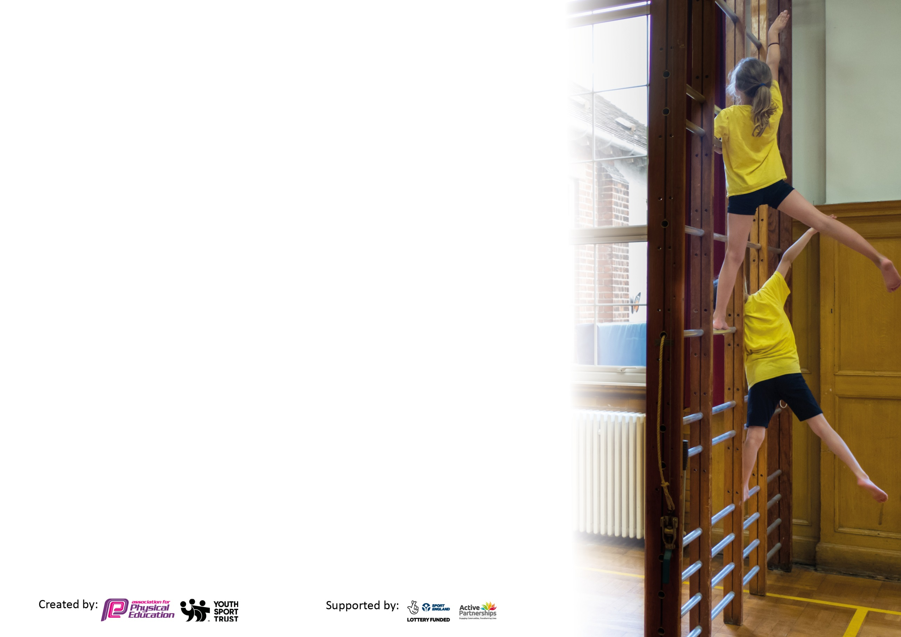
Please visit gov.uk for the revised DfE guidance including the 5 key indicators across which schools should demonstrate an improvement. This document will help you to review your provision and to report your spend. DfE encourages schools to use this template as an effective way of meeting the reporting requirements of the Primary PE and sport premium.

We recommend you start by reflecting on the impact of current provision and reviewing the previous spend.

Schools are required to publish details of how they spend this funding, including any under-spend from 2019/2020, as well as on the impact it has on pupils’ PE and sport participation and attainment by the end of the summer term or by 31st July 2021 at the latest.

We recommend regularly updating the table and publishing it on your website throughout the year. This evidences your ongoing self-evaluation of how you are using the funding to secure maximum, sustainable impact. Final copy must be posted on your website by the end of the academic year and no later than the 31st July 2021. To see an example of how to complete the table please click HERE.

Please note: Although there has been considerable disruption in 2020 it is important that you publish details on your website of how you spend the funding - this is a legal requirement.
Support for review and reflection - considering the 5 key indicators from DfE, what development needs are a priority for your setting and your pupils now and why? Use the space below to reflect on previous spend and key achievements and areas for development.

N.B. In this section you should refer to any adjustments you might have made due to Covid-19 and how these will influence further improvement.
Key achievements to date until July 2020: | Areas for further improvement and baseline evidence of need:
Silver Award achieved from Change 4 Life ( previously Bronze)  Have submitted application for Gold  Won District Sports in division 2019  School expected to achieve the Gold award from School Games  ( Due to Coronavirus Lockdown , no Games Mark awarded but we were awarded School Games Certificate in recognition to our ‘Ongoing commitment to Physical Activity’ and also awarded School Games mark for virtual Programme of sports in Summer Term.’ | - Identify staff training needs in light of proposals  - Undertake Imoves whole school audit or similar.  - Review existing provision  - Maintain and develop a robust method for tracking pupil participation and involvement including vulnerable groups.  - Develop school video/ IT resources for training in PE  - Incorporate imoves into the cross curricular planning  Commentary of individual impact of COVID-19 given in relevant key indicators.  (£11004 spent to date with £9324 to be carried over as now permitted by the Government due to the ongoing effects of COVID 19– much of this money will be allocated to replace arcane gym equipment; supplement the increased swimming budget from September 21 and to provide more playtime equipment in Key stage 1)

Did you carry forward an underspend from 2019-20 academic year into the current academic year? YES Delete as applicable
Total amount carried forward from 2019/2020 £2528
+ Total amount for this academic year 2020/2021 £17800
= Total to be spent by 31st July 2021. £20328.
Meeting national curriculum requirements for swimming and water safety.

N.B Complete this section to your best ability. For example you might have practised safe self-rescue techniques on dry land which you can transfer to the pool when school swimming restarts.
Due to exceptional circumstances priority should be given to ensuring that pupils can perform safe self rescue even
if they do not fully meet the first two requirements of the NC programme of study.
What percentage of your current Year 6 cohort swim competently, confidently and proficiently over a distance of at least 25 metres?  N.B. Even though your pupils may swim in another year please report on their attainment on leaving primary school at the end of the summer term 2021.  Please see note above. | %  75
What percentage of your current Year 6 cohort use a range of strokes effectively [for example, front crawl, backstroke and breaststroke]?  Please see note above. | %  78
What percentage of your current Year 6 cohort perform safe self-rescue in different water-based situations? | %  41
Schools can choose to use the Primary PE and Sport Premium to provide additional provision for swimming but this must be for activity over and above the national curriculum requirements. Have you used it in this way? | No  Each year , money is allocated to provide additional swimming for year 5 and 6 pupils who have not met the above criteria by taking an audit of pupil in Years 5 &6 ( This was also part of our plan for this year, however, the COVID 19 Lock down has meant this has not been the case. As a result, there are no up to date figures.  *The figures shown are based on an a parent questionnaire given to year 6 parents July 21 ( although not ideal, this level of proof is normally deemed sufficient for off- site visits)–  The figure for safe self-rescue is low but this is probably due to many parents selecting the ‘Not sure’ option (this will be recorded as a ‘No’ for the purpose of this survey).  However, the school has significantly addressed the allocation of PE time to Swimming and been in contact with Swim England regarding the content of the PE Swimming Curriculum.  The school is actively looking to fund catch up lessons in swimming for the Year 6 Cohort (21-21).

Action Plan and Budget Tracking
Capture your intended annual spend against the 5 key indicators. Clarify the success criteria and evidence of impact that you intend to measure to evaluate for pupils today and for the future.

Academic Year: 2020/21 | Total fund allocated: £20328 | Date Updated: July 21
Key indicator 1: The engagement of all pupils in regular physical activity – Chief Medical Officers guidelines recommend that primary school pupils undertake at least 30 minutes of physical activity a day in school |  |  |  | Percentage of total allocation:
 |  |  |  | %
Intent | Implementation |  | Impact | 13.7 (£2794.82)
Your school focus should be clear what you want the pupils to know and be able to do and about  what they need to learn and to  consolidate through practice: | Make sure your actions to achieve are linked to your intentions: | Funding allocated: | Evidence of impact: what do pupils now know and what can they now do? What has changed?: | Sustainability and suggested next steps:
Introduce activities to make every child active beyond PE lessons . | (i)Foundation/Infant children to have access to more apparatus encouraging them to physically explore and interact with their environment-  ii) KS2 playground equipment | i)EYFS Wheel barrows x2  £95.90 +VAT  i) EYFS brooms for outdoor play £36.95 +VAT  i)EYFS forks and trowels  £22.95 +VAT  i)EYFS gardening sand and shovel  £16.99 +VAT  i)Four hoop basketball net  £159.95+VAT  i)EYFS Super sporting pie  £24 +VAT  i)EYFS squeezy tweezers  £11+VAT  i)EYFS counting owls  £21 +VAT  i)EYFS Wheel barrows x2  £96 +VAT  i)EYFS jumbo eyedroppers  £14.50 +VAT  i)EYFS Links  £19  i)EYFS sorting set  £32  i)Year 1 constructa den class pack  £319.95 +VAT  i)Year 1 constructa den class pack  £319.95 +VAT  i)Year 1 Water world channelling set  £184.90 +VAT  i)Year 1 TTS portable frame cave set*  £112.95 +VAT  i)Year 1 team builder walker set £141.90 +VAT  i)Year 1 Assorted playground balls £35 +VAT  i)Year 1 Balance river stones £42.95 +VAT  i)Year 1  Outdoor traversing pulley system £44.95 +VAT  i)Year 1 Den building kit with crates £289.95*  +VAT  i)Year 1 Simple plank pack and stack centre  £116.99 +VAT  i)Year 1 Tyre stands £112.49+VAT  i)Year 1 Wigwam crane grips £5.99+VAT  i)Year 1 Green tarpaulin £14.99 +VAT  i)Year 2  Yoga carpet  £155.42  i)Year 2  Balance slider  £53.87  i)Year 2  movin monkeys  £46.68  i)Year 2  limbo pack  £30.75  i)Year 2  parachute  £94.50  i)Year 2  giant snakes and ladders  £45.16  i)Year 2  target maths  £33.68  i)Year 2  skimmed foam balls  £19.99  i)Year 2  balloon pumps x 3. £ 9.75  i)Year 2  balloons x2  £13.50  ii)KS2 Tennis balls £24  ii) Footballs £15 | Feedback from Foundation stage staff based on observations and discussions with children say that children are thrilled with the new pay equipment and are desperate to be out in all weathers.  Pupils stamina improved since the start of the year the start of the year.  Pupils’ gross motor skills and fine motor skills improved as a direct impact of the play equipment.  Children’s core body strength and arm and wrist strength improved as a direct result.  Opportunities for outdoor play has further increased/ acted upon.  Many children appeared to be more unfit and less toned at the start of the academic year as a consequence of sedentary lifestyles during the first lockdown but fitness levels etc have largely been restored.  Children’s well being positively impacted.  Many children playing with the new equipment who would not normally do so – eg some boys in ks 2 playing with footballs for the first time.  Pupils’ basic skils in catching improved | Apparatus can be used for subsequent years and, following evaluation, can be augmented appropriately.  Children become increasingly willing to run and continue to voluntarily do walk during break time.  Children spontaneously initiate new play ideas and extend these beyond the school day
Key indicator 2: The profile of PESSPA being raised across the school as a tool for whole school improvement |  |  |  | Percentage of total allocation:
 |  |  |  | %
Intent | Implementation |  | Impact | 9.2 (£1880)
Your school focus should be clear what you want the pupils to know and be able to do and about  what they need to learn and to  consolidate through practice: | Make sure your actions to achieve are linked to your intentions: | Funding allocated: | Evidence of impact: what do pupils now know and what can they now do? What has changed?: | Sustainability and suggested next steps:
(i)Sports /physical activity embedded across the school curriculum.  (ii)Sports activities celebrated in celebration assembly. Linking sports competitions to to the House System so each child feels involved.  (iii) Parents encouraged to become involved in sporting events and so set positive role model for students.  (iv) Sports ambassadors and Health Leaders to have higher profile  (v) School to hold PE curriculum Day  Vi) School to promote Health, Healthy eating, well being, and participation  Vii) Equipment audit /safety check to take place to ensure safety | (i)Enrol for the immoves ‘Active School programme’. (from Sep20)  Total review of the PE curriculum to look for links with curriculum subjects.  ii) Pupils to lead some assemblies.  (iii) implement several activities such as a family golden mile  (iv) Pupils lead assemblies and contribute their own web page on the school website and noticeboard. Match reports posted to parents via newsletter.  (v) Subject leader to organize and lead whole school Golden Mile Activity as part of the Well being Fortnight.  Vi)  Curriculum Visions Online library and resources purchased.  Design and Technology curriculum adapted to promote healthy eating  vii) Initial audit to be carried out by staff to remove arcane equipment and subsequent safety check and repair by external agencies | - £990  - No cost  - No Cost  Due to Bubbles and lock down – this was suspended until next year (assuming no further lockdowns)  (iv) No cost  (iv) £200 for sports ambassador and Health Leader training.  (v) No cost  (vi) see. Point (i)  vii)  safety check and repairs £350 | (i)Activity review prior to and after implementation to indicate greater physical activity across school.  Pupils love some of the activities which can be done in class .  Pupils were able to engage in PE lessons set via the imoves platform during lockdown.  Teachers and TA’s feel more positive about including physical activity/ movement/ dance components to some lessons  New curriculum includes links with imoves across other foundation subjects.  ii) Due to bubbles and lockdown, this has been difficult to achieve but the School Sports Council helped initiate several whole school initiatives in conjunction with “School Games” e.g . inter class speed stack challenge.  (ii)Pupil voice to record pupils’ attitude to sport ( expected to be positive)- Suspended due to Lock down  (iii) Pupils have greater interest in sporting activities through notice board was curtailed due to movement restrictions and limited involvement in inter school sports due to COVID  (iv) and (v) pupils helped organise alternative sports day and were excellent role models in the execution of their duties.  - Pupils unanimous in their positive endorsement of the day (Sports Hour Day)  Staff commented on the ‘buzz’ from the children.  vi) The curriculum Visions allows pupils ( including those with reading difficulties) as well as Sports Ambassadors to use full range of books, videos, audible books etc on Healthy eating, well being, nutrition etc –See also section 3(v) .  vii) School compliant with safety regulations. | (i)Assuming positive review of the scheme at the end of the year, school to sign up for future years at reduced rates.  New PE curriculum will lead to consistent, focused and improved PE teaching across the school.  (ii)This is to be continued indefinitely. More pupils involved in leading assemblies.  (iii) Noticeboard to be regularly updated in subsequent years  (iv) Sports ambassadors/ Health leaders appointed every September.  (v)) Future whole school events can be arranged at minimal costs – staff confidence and increasing expertise to be drawn upon.  vi)  can be accessed at home so provides greater school – home links.  vii) Although gym largely out of use due to COVID , equipment ready to start new focused curriculum in September.

Key indicator 3: Increased confidence, knowledge and skills of all staff in teaching PE and sport |  |  |  | Percentage of total allocation:
 |  |  |  | %
Intent | Implementation |  | Impact | 7.2 (£1460)
Your school focus should be clear | Make sure your actions to | Funding | Evidence of impact: what do | Sustainability and suggested
what you want the pupils to know | achieve are linked to your | allocated: | pupils now know and what | next steps:
and be able to do and about | intentions: |  | can they now do? What has
what they need to learn and to |  |  | changed?:
consolidate through practice:
To improve progress and achievement of all pupils the following foci apply:  (i) to move the sports teaching from good to outstanding in the present/immediate future  (ii-iv ) to invest in training and upskilling other school staff to maintain this  iv)  Staff and pupils make greater use of new technologies for training and delivering lessons which allow for more focused assessment and coaching. | - Review and rewrite the PE curriculum to make it consistent and ensure that the topics/ subjects followed build skills in a spiral curriculum.  Teacher to run and instigate after school clubs and lunchtime clubs and empower older pupils to do the same.  (ii)  Subject leader deliver INSET training to rest of the staff.  (iii) Staff to receive external training and notifications for upskilling  (iv)To affiliate with Herts Sports Partnership (School Games)for ongoing advice and training. | (i)  £ No cost  ii) No Cost  iii)TBA  (iii)  £400 Training postponed for this year (Covid)  )£1300 annual membership plus £160 for conference. | Pupils receiving high quality teaching in PE.  Greater participation in inter school events- this was reduced although the school did still manage to conduct some intra-school events and virtual interschool events via the School Games Programme  PE will have a much higher profile and roles of ambassadors and Health Leaders more defined and active.  (ii) INSET planned with staff confidence and expertise increased as a result.  There has been an increase in teachers taking after school clubs and competitions.  (iii) N/A COVID  (iv) Conference cancelled due to COVID but staff able to avail themselves of online training through school Games affiliation in lieu of this  iv) SGO is main conduit between school and others for support and developing new sporting experiences for the pupils. | (ii- iv ) Training of staff by external bodies to be continued for the duration of the additional funding.  Skills and training to be passed on in house in subsequent years  There has been an increase in teachers taking after school clubs and competitions.  iv) Teachers able to take after school sports clubs allowing sports coach to attend fixtures.  (iv) Herts Sports Partnership affiliation set to continue.  Other bodies to support the school to be identified.
Key indicator 4: Broader experience of a range of sports and activities offered to all pupils |  |  |  | Percentage of total allocation:
 |  |  |  | %
Intent | Implementation |  | Impact | 22.2 (£4519.90)
Your school focus should be clear | Make sure your actions to | Funding | Evidence of impact: what do | Sustainability and suggested
what you want the pupils to know | achieve are linked to your | allocated: | pupils now know and what | next steps:
and be able to do and about | intentions: |  | can they now do? What has
what they need to learn and to |  |  | changed?:
consolidate through practice:
(i) Continue to offer a wider range of activities both within and outside the curriculum to get more pupils involved.  - To focus particularly on those pupils who, in the past, have not taken up additional PE and Sports activities and/ or those for whom sporting endeavour presents a challenge.  - To introduce new sports  - KS2 Playground Equipment to encourage greater activity | (i)Introduce speed stacking club; Daily mile challenge introduced  table tennis tables to be purchased for KS2 playground.  Orienteering course to be established.  i)Cover for Sports teacher and PE Lead when training / taking children out of school during school hours  - Purchase sundry equipment for pupils who do not usually participate eg shin pads for those new to football  (ii)  KS2 & KS1 to start cardiovascular warm up to PE lessons.(see Yoga Mats  - Existing clubs to continue with new clubs made available – list of clubs circulated to parents termly.  ii) Playground leaders to assist in organising / assisting Teacher at break and lunch time activities/ PPG free clubs | £800 cover for  Sports teachers  (postponed due to COVID)  - Shinpads and other sundries  £20  (iii)  3 class sets of yoga/ HIIT mats  £550  (ii) (200)allocated to fund PPG pupils to attend after school clubs.  (iii)£50 for sundry costs for orienteering course.  (iv)See reference in Key indicator 1  (iv)*  20 Chrome books purchased  £1930 + £2299.90 | Additional achievements:  More children involved in games in KS1 and foundation stage.  Sports leaders leading games at break times expected in Non-COVID YEARS  (i)Orienteering course and other similar activities postponed due to COVID  Pupils who had never played football previously very keen to continue now that they have ‘caught the bug’  - Access given so that more children involved in sports vand games in all key stages although due to COVID the range of after school clubs was limited due to preservation of bubbles.  (iv ). Due to partitioning of the playground, the purchase of large apparatus was suspended –  (iv)*  However, due to the impact of the second lockdown – the school was able to purchase several chrome books to enable pupils with hitherto limited access to an online curriculum to avail themselves of the online PE offer and other subjects and of course the other benefits of well being . | ( I v)  Hardware can be used for years to come -and derived skills will be used for a lifetime.

Key indicator 5: Increased participation in competitive sport |  |  |  | Percentage of total allocation:
 |  |  |  | %
Intent | Implementation |  | Impact | 1.7 (£350)
Your school focus should be clear | Make sure your actions to | Funding | Evidence of impact: what do | Sustainability and suggested
what you want the pupils to know | achieve are linked to your | allocated: | pupils now know and what | next steps:
and be able to do and about | intentions: |  | can they now do? What has
what they need to learn and to |  |  | changed?:
consolidate through practice:
- Increased numbers of children participating in competitive sports including pupils from focus groups.  - Increased sporting activity during break times and lunch times.  - All children in Years 4, 5 and 6 who want to play for a school football team to be given that opportunity to play against another school. | (i) Competitions to be entered include:  Athletics; speed stacking; kwik cricket; football (several competitions); netball; swimming galas.  Football friendly matches to be arranged with a particular focus on children who do not normally get to play in the formal competitions.  Inclusion games  et al  School to field A team, Cup Team in competitions and Girls friendly B team .  Girls’ team to be entered into league competition.  iii) Pitch re-lined | (i)  £50 sundry costs such as competition fees.  £100 for engraving of trophies-  iii) Relining pitch £150 | (i)Sports teams exceeded or met expectations in competitions.  (Some competitions were cancelled due to coronavirus lockdown)  Many children canvassing for friendly competitions against other schools, particularly focus on girls and those who are unable to break into the first team.***  Friendly football matches for boys and girls in Y4-6 already taken place and others scheduled. ( School was on target to meet its goal regarding football participation for all)***  Audit of focus pupils to be taken and evaluated over time to show positive impact after ***  *** The COVID restrictions meant that many competitions and scheduled friendly matches were cancelled but the school did manage to enter a football tournament where the team punched above their weight and other pupils were able to play af friendly match.  School did enter virtual competitions with other schools for the first time via School Games. | Although this year has made it very challenging to deliver competitive sports with other schools, the infrastructure is there for its resumption.  There has been an increase in teachers taking after school clubs and competitions.

Signed off by
Head Teacher:
Date:
Subject Leader: | Kevin Creaton
Date: | 16 July2021
Governor:
Date:

