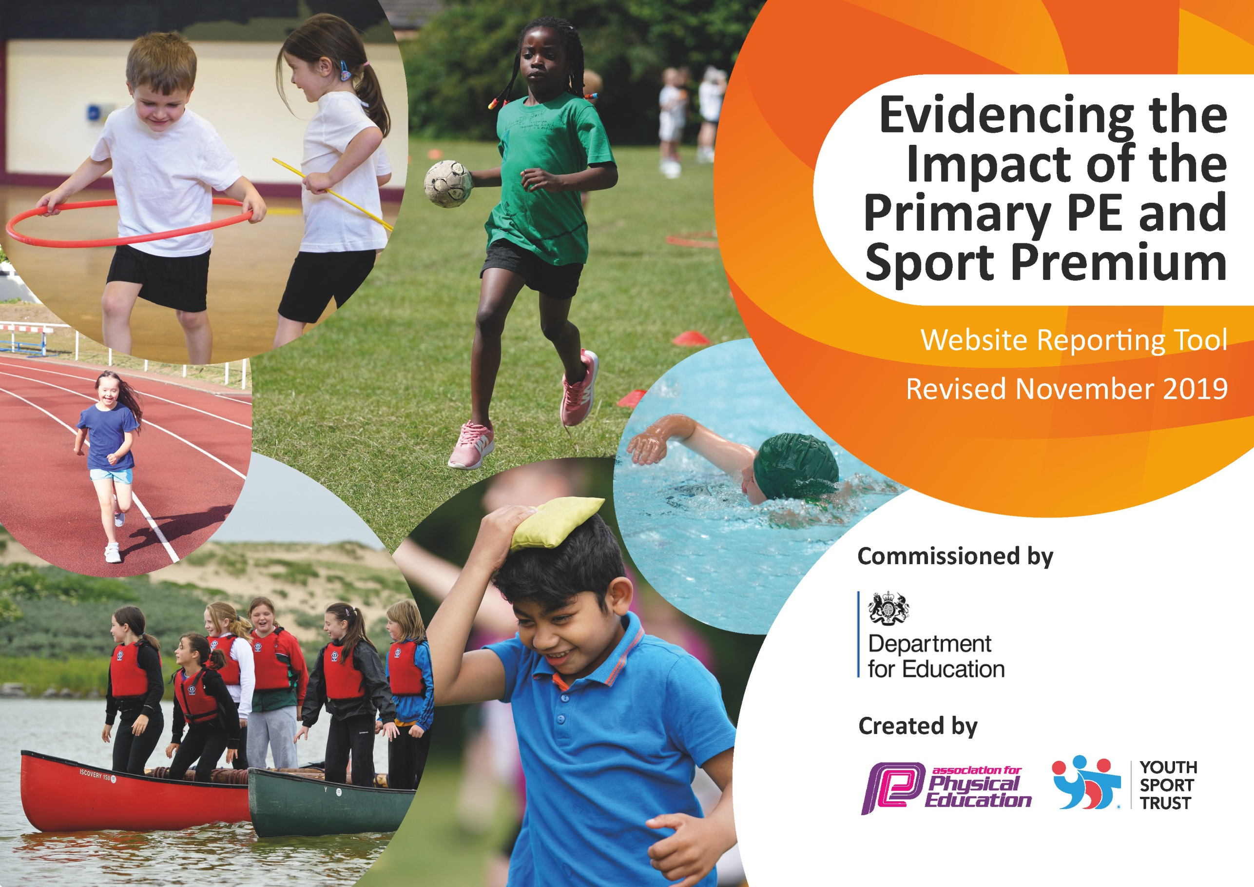
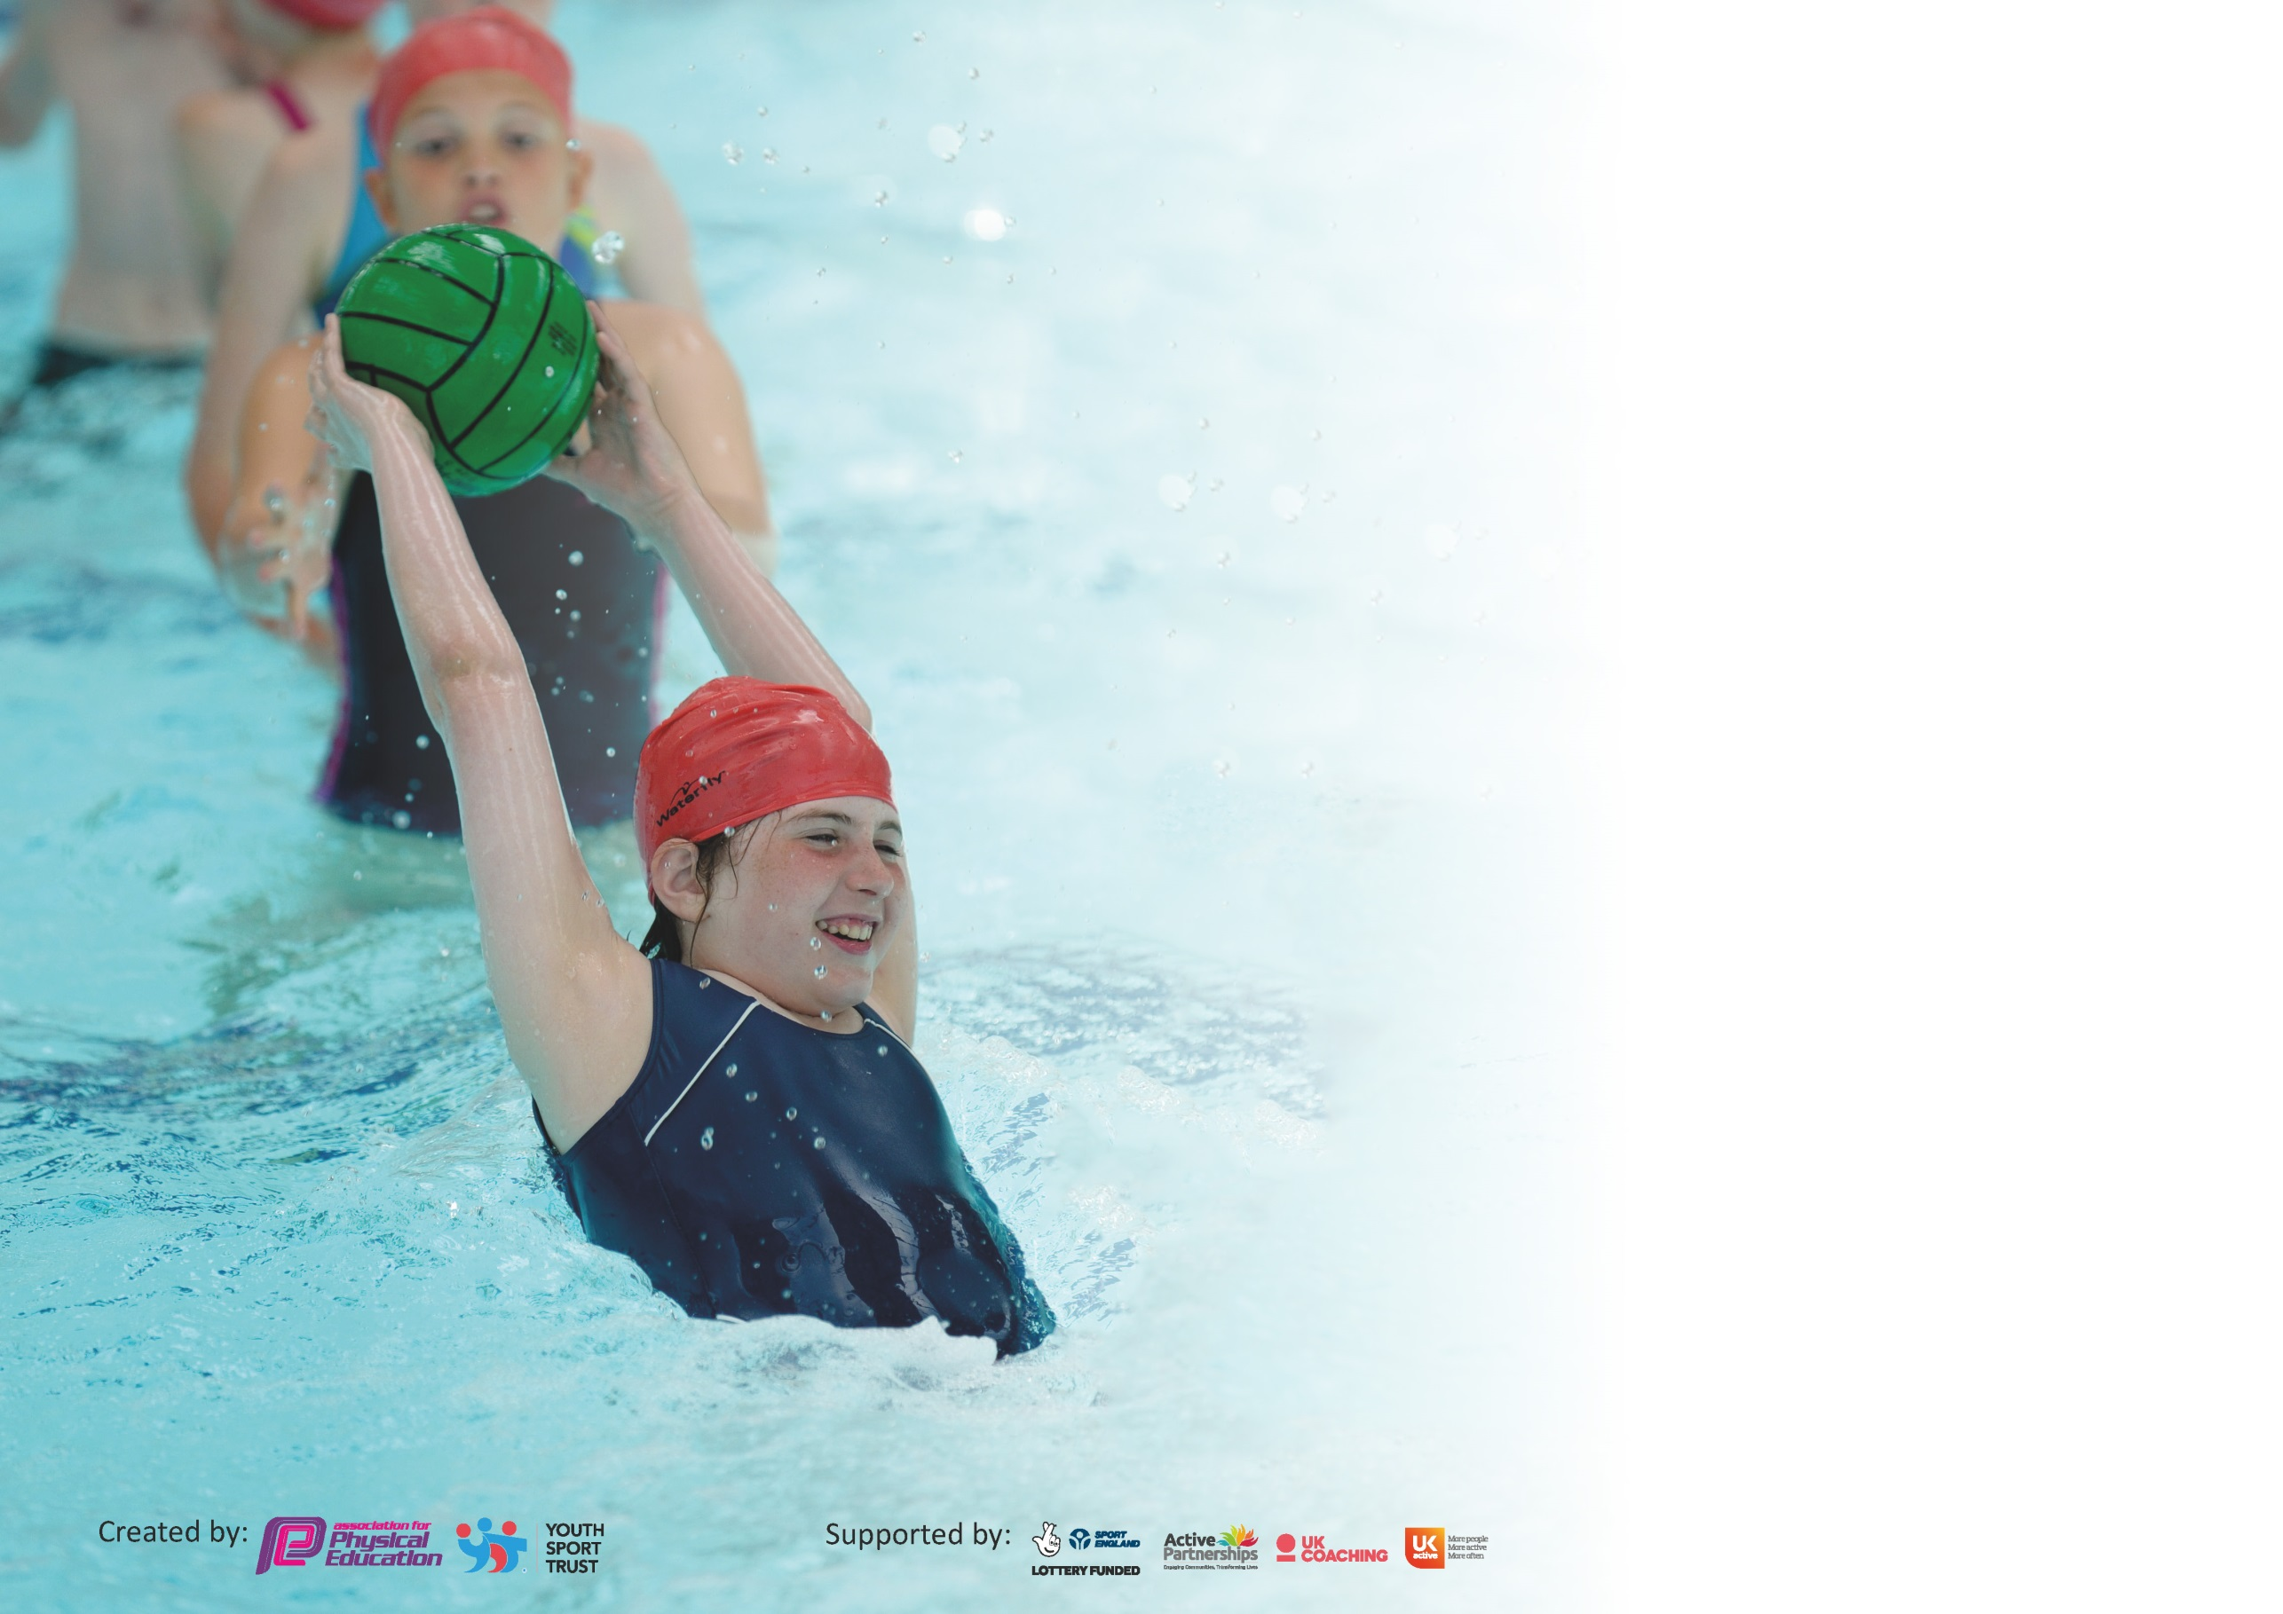

It is important that your grant is used effectively and based on school need. The Education Inspection Framework (Ofsted 2019 p64) makes clear there will be a focus on ‘whether leaders and those responsible for governors all understand their respective roles and perform these in a way that enhances the effectiveness of the school’.

Under the Quality of Education criteria (p41) inspectors consider the extent to which schools can articulate their curriculum (INTENT), construct their curriculum (IMPLEMENTATION) and demonstrate the outcomes which result (IMPACT).

To assist schools with common transferable language this template has been developed to utilise the same three headings which should make your plans easily transferable between working documents.

Schools must use the funding to make additional and sustainable improvements to the quality of Physical Education, School Sport and Physical Activity (PESSPA) they offer. This means that you should
use the Primary PE and Sport Premium to:

- Develop or add to the PESSPA activities that your school already offer
- Build capacity and capability within the school to ensure that improvements made now will benefit pupils joining the school in future years

Please visit gov.uk for the revised DfE guidance including the 5 key indicators across which schools should demonstrate an improvement. This document will help you to review your provision and to report your spend. DfE encourages schools to use this template as an effective way of meeting the reporting requirements of the Primary PE and Sport Premium.

We recommend you start by reflecting on the impact of current provision and reviewing the previous spend.

Schools are required to publish details of how they spend this funding as well as on the impact it has on pupils’ PE and sport participation and attainment by the end of the summer term or by 31st July 2020 at the latest.

We recommend regularly updating the table and publishing it on your website throughout the year. This evidences your ongoing self-evaluation of how you are using the funding to secure maximum, sustainable impact. Final copy must be posted on your website by the end of the academic year and no later than the 31st July 2020. To see an example of how to complete the table please click HERE.

Support for review and reflection - considering the 5 key indicators from DfE, what development needs are a priority for your setting and your pupils now and why? Use the space below to reflect on previous spend and key achievements and areas for development.

Key achievements to date until July 2019: | Areas for further improvement and baseline evidence of need:
Silver Award achieved from Change 4 Life ( previously Bronze)  Have submitted application for Gold  Won District Sports in division 2019 | - Identify staff training needs in light of proposals  - Undertake IMoves whole school audit.  - Review existing provision  - Maintain and develop a robust method for tracking pupil participation and involvement including vulnerable groups.  - Develop school video/ IT resources for training in PE  - Incorporate imoves into the cross curricular planning

Meeting national curriculum requirements for swimming and water safety.
What percentage of your current Year 6 cohort swim competently, confidently and proficiently over a distance of at least 25 metres?  N.B. Even though your pupils may swim in another year please report on their attainment on leaving  primary school at the end of the summer term 2020. | 81%*
What percentage of your current Year 6 cohort use a range of strokes effectively [for example, front crawl, backstroke and breaststroke]? | 81%*
What percentage of your current Year 6 cohort perform safe self-rescue in different water-based situations? | 81%*
Schools can choose to use the Primary PE and Sport Premium to provide additional provision for swimming but this must be for activity over and above the national curriculum requirements. Have you used it in this way? | Yes/No  Each year , money is allocated to provide additional swimming for year 5 and 6 pupils who have not met the above criteria by taking an audit of pupil in Years 5 &6 ( This was also part of our plan for this year, however, the COVID 19 Lock down has meant this has not been the case. As a result, there are no up to date figures.  *The figures shown are based on an assessment made in 2018 by the swimming instructors – The information details the number of pupils who could swim 25 m – They are taught a range of strokes and are asked to get out of the pool via the side and not the steps but here was no breakdown in figures given - for the purposes of this document, it is assumed that the figures for those swimming a range of strokes and those who can self- rescue are similar to those listed as being able to swim 25m.

Action Plan and Budget Tracking
Capture your intended annual spend against the 5 key indicators. Clarify the success criteria and evidence of impact that you intend to measure to evaluate for pupils today and for the future.
COVID / LOCK DOWN AFFECTED /POSTPONED ITEMS HIGHLIGHTED IN BLUE

Academic Year: 2019/20 | Total fund allocated: £17770 | Date Updated: 23-7-2020
Key indicator 1: The engagement of all pupils in regular physical activity – Chief Medical Officer guidelines recommend that primary school pupils undertake at least 30 minutes of physical activity a day in school |  |  |  | Percentage of total allocation:
 |  |  |  | 3 %
Intent | Implementation |  | Impact
Your school focus should be clear what you want the pupils to know and be able to do and about  what they need to learn and to  consolidate through practice: | Make sure your actions to achieve are linked to your intentions: | Funding allocated: | Evidence of impact: what do pupils now know and what can they now do? What has changed?: | Sustainability and suggested next steps:
Introduce activities to make every child active beyond PE lessons . | (i)Foundation/Infant children to have access to more apparatus encouraging them to physically explore and interact with their environment- More Hoops/ beanbags/ infant basketball trainers purchased  (ii)  KS2 & KS1 to start cardiovascular warm up to PE lessons.  (iii) Infant and Early Years Staff issued with St Adrian’s branded outdoor sweatshirts to encourage outdoor play.  (iv)Whole school Skip to be Fit day with ongoing weekly progress checks 2-minute fitness challenge”.  (see note in impact column) | i)£250  basketball trainer  i)£170  Hoops bean bags  iii)£200  Hoodies | Feedback from Foundation stage staff based on observations and and discussions with children (formal pupil voice did not take place due to lock down)  Pupils made constant use of additional equipment at play times.  Pupils stamina improved since the start of the year the start of the year.  Opportunities for outdoor play has further increased/ acted upon.  Gym activities incorporated into some PE lessons  Children’s attitude and participation to gym activities expected to be very positive  Number of children participating in lunch time clubs increasing.(up until lock down)  Children’s performance in the 2-minute fitness challenge expected to show steady progression- Due to lockdown, 2 minute challenge did not take place, however UKS2 pupils devised various skipping challenges (social distancing friendly) between bubbles – times for completing challenges typically improved by over 100%  All children improved their participation and PBs | Apparatus can be used for subsequent years and, following evaluation, can be augmented appropriately.  Children become increasingly willing to run and continue to voluntarily do the mile during break time.  Sports leaders set example for subsequent sports leaders to carry out/ lead activities.
Key indicator 2: The profile of PESSPA being raised across the school as a tool for whole school improvement  (Physical Education, School Sport and Physical Activity) |  |  |  | Percentage of total allocation:
 |  |  |  | 9 %
Intent | Implementation |  | Impact
Your school focus should be clear what you want the pupils to know and be able to do and about  what they need to learn and to  consolidate through practice: | Make sure your actions to achieve are linked to your intentions: | Funding allocated: | Evidence of impact: what do pupils now know and what can they now do? What has changed?: | Sustainability and suggested next steps:
(i)Sports /physical activity embedded across the school curriculum.  (ii)Sports activities celebrated in celebration assembly. Linking sports competitions to to the House System so each child feels involved.  teaching of PE  (iv) Parents encouraged to become involved in sporting events and so set positive role model for students.  (v) Sports ambassadors and Health Leaders to have higher profile  (vi) School to hold PE curriculum Day  Vii) School to promote Health, Healthy eating, well being, and participation  Viii) Visit from Inspirational Speaker | (i)Enroll for the iMmoves ‘Active School programme’. (from Sep19)  ii) Pupils to lead some assemblies.  (  (iv) Participate in St Albans City FC membership scheme.  Pupils and parents run the golden mile prior to school for sports relief.  School to run Euro 2020 Bonanza competition for all pupils and their families.  (v) Pupils lead assemblies and contribute their own web page on the school website and noticeboard. Match reports posted to parents via newsletter.  (vi) Subject leader to organize and lead whole school Golden Mile Activity as part of the Well being Fortnight.  Vii)  Curriculum Visions Online library and resources purchased.  Viii) Visit from Rachel MacKenzie (Former World Thai Boxing Champion) | - £990  - No cost  (iv) No cost  (v) £200 for sports ambassador and Health Leader training.  (vi) No cost  (vii)  £340  (viii) No Cost | (i)Activity review prior to and after implementation to indicate greater physical activity across school.  Pupil voice survey expected to endorse greater physical activity in the classroom.  Teachers and TA’s feel more positive about including physical activity/ movement/ dance components to some lessons  (ii)Pupil voice to record pupils’ attitude to sport ( expected to be positive)- Suspended due to Lock down  (iii) Pupils have greater interest in sporting activities through notice board.  (iv) Membership scheme was greeted with enthusiasm.  Children and parents ran the golden mile which was celebrated on the school noticeboard/ website.  Pupils and parents expected to be eagerly keen to see their progress in the competition.  (v) Pupils (and parents and carers) are keen to read about the sporting activities that are taking/ have taken place.  (vi) Pupils unanimous in their positive endorsement of the day.  Staff commented on the ‘buzz’ from the children.  Staff feeling more confident about delivering sports based activities to pupils of mixed age groups  vii) The curriculum Vsions allows pupils ( including those with reading difficulties) as well as Sports Ambassadors to use full range of books, videos, audible books etc on Healthy eating, well being, nutrition etc –See also section 3(v) .  Fantastic, inspiring speech about the power of perseverance and overcoming adversity and discrimination – Children and adults loved it - | (i)Assuming positive review of the scheme at the end of the year, school to sign up for future years at reduced rates.  (ii)This is to be continued indefinitely. More pupils involved in leading assemblies.  (iii) Noticeboard to be regularly updated  (iv) School to promote the scheme every September.  Other events in a similar vein can be organized to raise money for charity.  Competition to be replaced by  “European Cup Bonanza”  (Cancelled due to World Wide Pandemic)  (v) Sports ambassadors/ Health leaders appointed every September.  (vi) Future whole school events can be arranged at minimal costs – staff confidence and increasing expertise to be drawn upon.  vii)  can be accessed at home so provides greaterschool – home links.  Continue with programme of external speakers.

Key indicator 3: Increased confidence, knowledge and skills of all staff in teaching PE and sport |  |  |  | Percentage of total allocation:
 |  |  |  | 52 %
Intent | Implementation |  | Impact
Your school focus should be clear | Make sure your actions to | Funding | Evidence of impact: what do | Sustainability and suggested
what you want the pupils to know | achieve are linked to your | allocated: | pupils now know and what | next steps:
and be able to do and about | intentions: |  | can they now do? What has
what they need to learn and to |  |  | changed?:
consolidate through practice:
To improve progress and achievement of all pupils the following foci apply:  (i) to move the sports teaching from good to outstanding in the present/immediate future  (ii-iv ) to invest in training and upskilling other school staff to maintain this  (v)  Improve staff skills in area of well being  (vi)  Staff and pupils make greater use of new technologies for training and delivering lessons which allow for more focused assessment and coaching. | (i) Employ dedicated sports teacher to deliver excellent teaching  Teacher to run and instigate after school clubs and lunchtime clubs and empower older pupils to do the same.  (ii) Coach to upskill staff through INSET and working alongside them.  Subject leader and coach to deliver INSET training to rest of the staff.  (iii) TA identified as a suitable candidate for further training to increase coaching level,  (iv)To affiliate with Herts Sports Partnership (School Games)for ongoing advice and training.  (v ) TA to be trained as Well Being Lead | (i)  £7500 (clubs and Non PPA time)- PPA cover to be allocated from staffing budget)  During summer term – additional hours spent with infants / early years in active play activities (NOT PPA COVER)  £400 Training postponed for this year (Covid)  - £1300 annual membership plus £160 for conference.  - £300  Briony Well being training  (vi)  new ipads to record activities for training use – and staff training.  £TBA | Coach appointed  Pupils receiving high quality teaching in PE.  Greater participation in inter school events.  PE has a much higher profile and roles of ambassadors and Health Leaders more defined and active.  (ii) INSET planned with staff confidence and expertise increased as a result.  (iii) Specialist Teacher to disseminate increased proficiency to staff and pupils.  (iv) TA to take a more prominent role in leading sports activities with a greater number and variety of pupils.  (v) HSP is main conduit between school and others for support and developing new sporting experiences for the pupils. | Coach will continue to be employed to maintain and further develop sporting excellence in the school.  (ii- iv ) Training of staff by external bodies to be continued for the duration of the additional funding.  Skills and training to be passed on in house.  iv) T A is able to take after school sports clubs allowing sports coach to attend fixtures.  (v) Herts Sports Partnership affiliation set to continue.  Other bodies to support the school to be identified.  - Hardware can be used for years to come -and derived skills will be used for a lifetime.
Key indicator 4: Broader experience of a range of sports and activities offered to all pupils |  |  |  | Percentage of total allocation:
 |  |  |  | 7 %
Intent | Implementation |  | Impact
Your school focus should be clear | Make sure your actions to | Funding | Evidence of impact: what do | Sustainability and suggested
what you want the pupils to know | achieve are linked to your | allocated: | pupils now know and what | next steps:
and be able to do and about | intentions: |  | can they now do? What has
what they need to learn and to |  |  | changed?:
consolidate through practice:
(i) Continue to offer a wider range of activities both within and outside the curriculum to get more pupils involved.  - To focus particularly on those pupils who, in the past, have not taken up additional PE and Sports activities and/ or those for whom sporting endeavour presents a challenge.  - To introduce new sports  - KS2 Playground Equipment to encourage greater activity | (i)Introduce speed stacking club; Daily mile challenge introduced  table tennis tables to be purchased for KS2 playground.  Orienteering course to be established.  i)Cover for Sports teacher and PE Lead when training / taking children out of school during school hours  New table tennis table and bats  - Existing clubs to continue with new clubs made available – list of clubs circulated to parents termly.  ii) Playground leaders to assist in organising / assisting Teacher at break and lunch time activities/ PPG free clubs  iii) Archery (£400)and ultimate Frisbee to be introduced (£450) plus free training day. Could we do an INSET on this for the Staff?  Maypole etc  iV) Purchase two mid size basketball nets | £50 for sundry costs for orienteering course.  £800 cover for  Sports teachers  £1000 table tennis  (ii) (300)allocated to fund PPG pupils to attend after school clubs.  (iii)  £850  iV) £130 (basket ball nets) | Additional achievements:  More children involved in sports and games in KS1 and foundation stage.  Sports leaders leading games at break times.  Large uptake of use of table tennis tables at break time  - Access given so that more children involved in sports and games in all key stages.  Archery and Frisbee postponed due to lock down -will consider Introducing them next year pending coronavirus advice. | Large uptake of table tennis tables anticipated and, if popular, more can be purchased so that table tennis can be formally introduced to the teaching PE curriculum ( racquet/ bat and ball skills)  (NOT purchased due to Lock down /bubble issues-to be addressed in 2020-2021 budget) Orienteering Course Postponed pending COVID Advice  (ii) Engaging children in sports activities

Key indicator 5: Increased participation in competitive sport |  |  |  | Percentage of total allocation:
 |  |  |  | 15 %
Intent | Implementation |  | Impact
Your school focus should be clear | Make sure your actions to | Funding | Evidence of impact: what do | Sustainability and suggested
what you want the pupils to know | achieve are linked to your | allocated: | pupils now know and what | next steps:
and be able to do and about | intentions: |  | can they now do? What has
what they need to learn and to |  |  | changed?:
consolidate through practice:
- Increased numbers of children participating in competitive sports including pupils from focus groups.  - Increased sporting activity during break times and lunch times.  - All children in Years 4, 5 and 6 who want to play for a school football team to be given that opportunity to play against another school. | (i) Competitions to be entered include:  Athletics; speed stacking; kwik cricket; football (several competitions); netball; swimming galas.  Purchase a designated laptop for PE Coach/Teacher to facilitate arranging fixtures- creating online risk assessments and communicating fixture information directly with parents using online links.  Football friendly matches to be arranged with a particular focus on children who do not normally get to play in the formal competitions.  Inclusion games  et al  School to field A team, B Team, Cup Team in competitions and Girls friendly B team .  Girls’ team to be entered into league competition.  Two new portable basket ball nets to be purchased with safety padding  iii) Pitch re-lined  iii)foot scraper  iii) Buy new football Goals | (i)  £200 sundry costs such as competition fees.  (i)  £600 for appropriate laptop  (i) £340 (BB cover for clubs)  £240 for new kit and £140 for extra socks and shorts and tops additional sports kits as increased numbers of participants.  £100 for engraving of trophies- Most tournaments cancelled  (2 X £311 from Costco plus  iii) £160 goals  iii) Relining £150  iii) £150 Scraper | (i)Sports teams exceeded expectations in competitions.  More children taking part in intra- school House Competitions.  More children taking part in extra-curricular activities linked to sporting competitions.  More children taking part in inter-school friendly matches.  (Some competitions were cancelled due to coronavirus lockdown)  School expected to achieve the Gold award from School Games  ( Due to Coronavirus Lockdown , no Games Mark awarded but we were awarded School Games Certificate in recognition to our ‘Ongoing commitment to Physical Activity’ and also awarded School Games mark for virtual Programme of sports in Summer Term.’  Many children canvassing for friendly competitions against other schools, particularly focus on girls and those who are unable to break into the first team.  Friendly football matches for boys and girls in Y4-6 already taken place and others scheduled. ( School was on target to meet its goal regarding football participation for all)  Audit of focus pupils to be taken and evaluated over time to show positive impact. | The school is already predisposed to sustain most of these measures.  Staff encouraged to receive further training to run clubs.

Signed off by
Head Teacher:
Date:
Subject Leader: | KEVIN CREATON
Date: | 27-07-2020
Governor:
Date:

