Dear Parents,
You have accepted a place at our school nursery where we will provide up to 15 hours of free childcare for your child.
Under the new regulations the school must now ask parents to complete an application form and sign a declaration each term to confirm that we are providing your child with 15 hours of care in order for us to reclaim the funds from the government.
We therefore ask that you complete the form on the website and return it to school as soon as possible.
If you are taking up more hours at a different setting or childminder in the afternoons you will also be required to complete a form for them so they can claim the balance of hours up to the maximum of 30 per week.
Without your completed declaration form we will be unable to reclaim the free hours and so would be unable to honour the offer of a place in the nursery
Yours sincerely
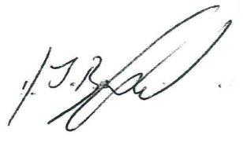
Dominic Bedford
Headteacher

