SCIENCE

Separating Materials.

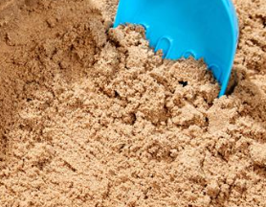 sand

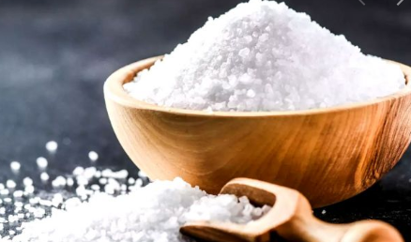 salt

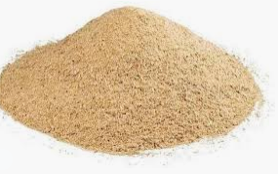 sawdust

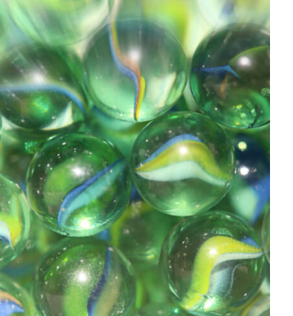marbles

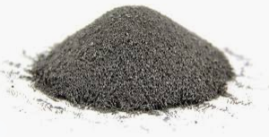 iron filings
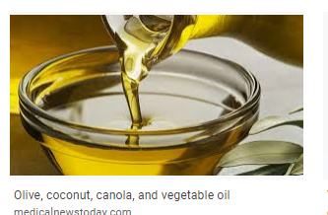

Your Task Choose one task below.

Imagine that you accidently mixed some of these things together.
Explain how, using things typically found in a home or school, you could separate a mixture of these things so that each substance was back on its own.

Tricky) A mixture of sawdust, iron filings, marbles and sand.

Double Tricky) A mixture of sawdust, iron filings, marbles ,sand and salt

Triple Tricky) A mixture of sawdust, iron filings, marbles ,sand, salt and cooking oil.

Good luck.

Mr C

Extension,

Perhaps you might try to do some separating experiments of your own ( safely with Mum or Dad around) to check out your ideas.

Mr C
Tricky - either pick out the marbles or use a colander to remove them.
A magnet (ideally wrapped in tissue paper) can remove the iron filings.
Add water and the sawdust will float and can be scooped off.
Pour away the water and you are left with sand.

Double tricky.
Tricky - either pick out the marbles or use a colander to remove them.
A magnet (ideally wrapped in tissue paper) can remove the iron filings.
Add hot water and the sawdust will float and can be scooped off and dried.
The sand will sink to the bottom and the salt will dissolve in the hot water to make a salt solution. (if you wanted to be more sophisticated, you can remove the sand from the salt water solution by using a filter such as coffee percolator filters or some cotton/muslin material.
Pour away the salt water solution and you are left with sand.
Let the salt water solution evaporate ( this may take some time but if you use a flat dish or heat it, it will be quicker). The water evaporates and solid salt is left behind.

Triple Tricky
The first thing to do is to separate the oil from coating the other materials.
Add very hot water to the mixture - this will help remove the oil from coating the marbles etc.
Pour the oily water /particle mixture through a colander into a pot - this will remove the marbles which can be collected in the colander.
The salt will dissolve in the very hot water to form a salt water solution - the oil and sawdust will be floating on the top.
Pour the contents of the pot through a sieve into another separate container.
This will remove the solids from the liquids -
Now you have a salt solution with a layer of oil on top. You can then scoop off the oil but it has been suggested that if you put the liquids in the freezer, when the salty freezes, you can just pour off the oil (Josh’s suggestion)*
With the salt solution , heat it up until the water evaporates leaving the salt behind.

You still have a mixture of iron filings and sand and sawdust.
Remove the iron filings using a magnet (wrapped in a tissue).
Add water to the sand and sawdust. The sawdust will float and can be scooped off and dried.

Pour away the water and dry the wet sand.

*(Depending on the oil , this may solidify before the salt water solution freezes so that would be very easy to remove as it floats on the surface. - also, you would need a very cold freezer as salt water freezes at a much lower temperature than normal water.)

Natalie

Triple tricky: For the marbles, you simply need to drain the mix, in a colander, and pick them out; to remove the sand, you will need to put your hand in the water and search at the bottom of the container. Then pick it out manually. With regards to the sawdust, you use a colander once more, in order to separate the materials, and put them in a separate bowl; to remove the iron fillings, dip a magnet into the water so that the metal is attracted to it; and finally - to get rid of the oil - you need to thoroughly mix it with the iron fillings (before taking those out) and they should come out with the fillings. Then, put it in a salad spinner and whizz quickly so that the oil is no longer mixed with the iron. Remember to put each item in a separate bowl after having taken them out of the solution.

Noah I did a mixture of water, cooking oil, sand, iron filings and salt. Firstly, I separated the cooking oil by skimming it off the top with a spoon. Next, I separated the water and salt from the rest by pouring the mixture on top of a fine material with a bowl underneath to catch the water and salt. After that, to take out the iron filings I used a magnet. Finally, to separate the salt from the water, put the salt and water out on a flat tray and wait for the water to evaporate.

Elizabeth --- If you accidentally mixed all of these materials together you can separate the marbles by using a sieve and with the sieve you can also separate the sawdust as well as the marbles. What you have left is the sand and the iron filings, to be able to separate the iron filings from the sand you need to hold a magnet close to the mixture and then the iron filings should come up to the magnet since the iron filings are iron and iron is a type of metal and magnets attract some kinds of metal.

Charlotte’s answer:
Tricky) A mixture of sawdust, iron filings, marbles and sand.

Firstly, the marbles can be removed using your hands.

To remove the iron filings from the mixture, use a magnet, swirl it around and make sure all filings have been collected.

Then, to remove the sawdust from the sand, blow air using a fan because the sand is heavier than the sawdust and will not move.

Emily --
Tricky) A mixture of sawdust, iron filings, marbles and sand.
First I would get all the marbles out. Now I am left with iron filings, sawdust and sand.Then to get the iron filings out I would get a magnit and hover it over everything.Now I have sawdust and sand left. Now I will put the sawdust and sand in a sieve ( hopefully one of them will have smaller grains so it will fall through the sieve and the other will not).

Double Tricky) A mixture of sawdust, iron filings, marbles ,sand and salt
Now the salt will be left with the sand. To separate these two I will pour hot water over them and the salt will dissolve and the sand will be left in the water.

Triple Tricky) A mixture of sawdust, iron filings, marbles ,sand, salt and cooking oil.
Now we have cooking oil, water and sand. The sand will sink to the bottom of the container and the cooking oil and water won’t mix. Water is more dense than cooking oil, so the cooking oil will float to the top.

Josh
First of all you need to tip all of the ingredients into a bowl of water.
Then, to get the marbles out, all you have to do is stick your hand in and pull them out because they are solid and so they don't mix with anything.
To get the iron filings out, just stick a magnet just under the surface and the iron filing will stick to it. The salt should dissolve so to get the oil out use a sieve so that the sand and sawdust get stuck in the sieve and the water and oil flow through to the bowl below. Then, to get the oil out, put the bowl of water and oil into the freezer . Then wait for the water to freeze and then the oil will end up on top of the frozen water/ice still as a liquid so you can just pour it out. To get the salt out, just evaporate the water so that the salt reappears. Then, to separate the sand and sawdust, wait for them to dry and then blow into the pile of sand and sawdust so that the sawdust comes off. The reason why this happens is because the sawdust is a lower density than the sand.

Roisin
Double Tricky:

Mixture- sawdust,iron filings, marbles, sand and salt.

Equipment-, magnet, Food colander strainer, saucepan, water and a spoon.

Method-
First, put all the mixture into a bowl/container.

Next, collect your spoon and carefully remove the marbles from the mixture.

After that, use the magnet to collect all the iron filings and place them in a separate bowl...Take your time doing this as the iron fillings are very fine.

Then, place the remaining mixture of sawdust, sand and salt through the food colander strainer to remove the saw dust.

Now you are left with the sand and salt. To separate these you will need to add some water to the mixture and boil in a pan. This will everapte the salt and leave the sand.

Finn
Triple Tricky) A mixture of sawdust, iron filings, marbles ,sand, salt and cooking oil.

A magnet can take out the metal filings

Pour some water in to dissolve the salt

Pick out the marbles

Sawdust will float to the top and the oil

Triple Tricky) A mixture of sawdust, iron filings, marbles ,sand, salt and cooking oil.

A magnet can take out the metal filings

Pour some water in to dissolve the salt

Pick out the marbles

Sawdust will float to the top and the oil

Sophie

TRICKY

You could use soap because I did an Experiment where I put some water in a bowl and put some pepper in the water and when I put soap on my finger and put it in the middle of the water the pepper glided away from the soap so the same thing could happen to the sawdust,iron filings,marbles and sand.

Ellie -
I think that the mixture of sawdust,iron filings,marbles and sand will be very soft and hard because sawdust and sand are soft and iron filings and marbles are hard.

Caidan

Tricky) A mixture of sawdust, iron filings, marbles and sand.
You can pick the marbles out of the mixture using tweezers or your fingers.
Using a magnet to separate the iron filings
Get a sieve to separate sand from sawdust

Double Tricky) A mixture of sawdust, iron filings, marbles ,sand and salt
As above.
Put the salt and sand mixture into a container.heat this mixture until the salt disappears.place a cloth over a bowl and pour the liquid to separate the sand.Now heat the water liquid until the water evaporates and you are left with salt.

Triple Tricky) A mixture of sawdust, iron filings, marbles ,sand, salt and cooking oil.
Pick the marbles out using tweezers
Use a magnet to separate iron filings
Pour water on remaking mixture
Scoop oil from the top of the liquid.
Boil until salt disappears.
Pour liquid through a muslin cloth, this is a salty water solution.
Boil the salty water until water evaporates leaving salt
Sieve the sawdust and sand to separate.

Sophie- My thoughts
Triple tricky

First, take the marbles out and that is the first item out. You then need to use something to drain the oil out into a cup without anything else going in.

