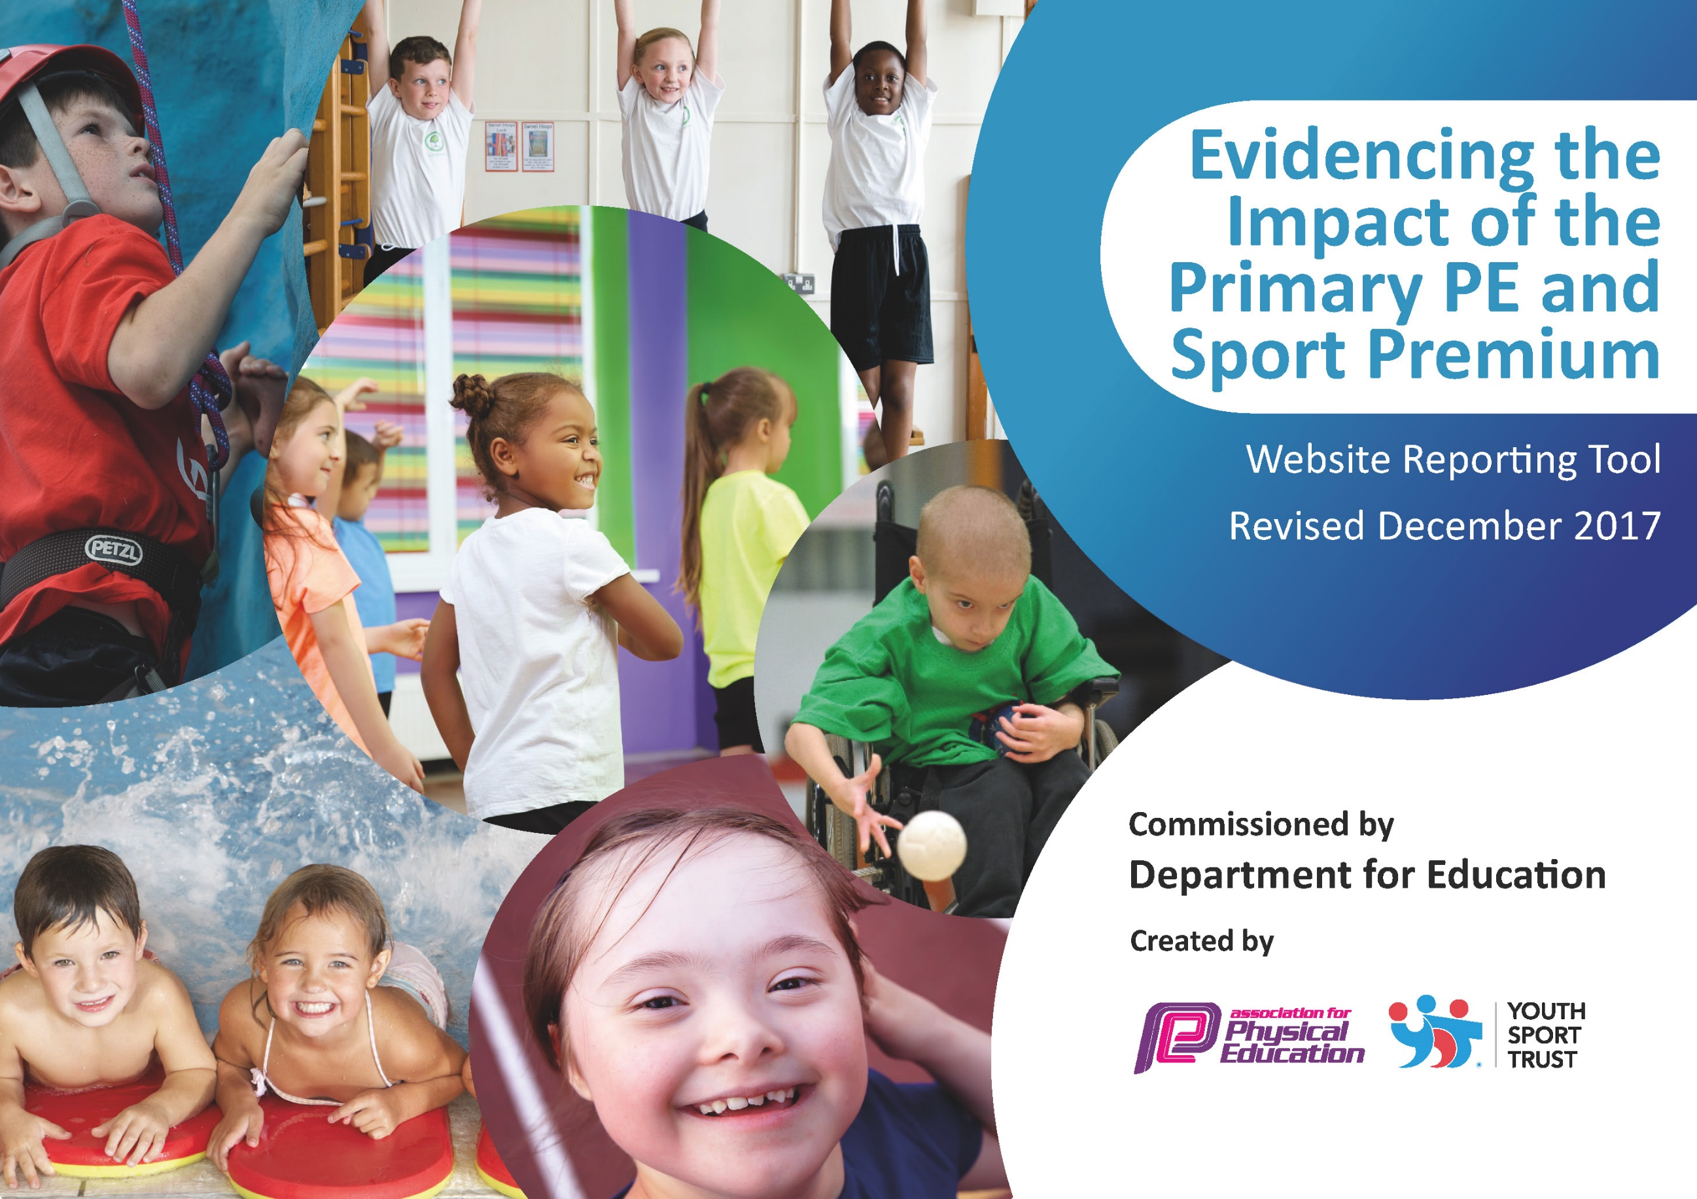

Schools must use the funding to make additional and sustainable improvements to the quality of PE and sport they offer. This means that you should use the Primary PE and Sport Premium to:

- develop or add to the PE and sport activities that your school already offers
- build capacity and capability within the school to ensure that improvements made now will benefit pupils joining the school in future years

Please visit gov.uk for the revised DfE guidance including the 5 key indicators across which schools should demonstrate an improvement. This document will help you to review your provision and to report your spend. DfE encourages schools to use this template as an effective way of meeting the reporting requirements of the Primary PE and Sport Premium.

We recommend you start by reflecting on the impact of current provision and reviewing the previous spend.
Under the Ofsted Schools Inspection Framework, inspectors will assess how effectively leaders use
the Primary PE and Sport Premium and measure its impact on outcomes for pupils, and how effectively governors hold them to account
for this.

Schools are required to publish details of how they spend this funding as well as on the impact it has on pupils’ PE
and sport participation and attainment.
We recommend regularly updating the table and
publishing it on your website as evidence
of your ongoing review into how you are using the money
to secure maximum, sustainable impact. To see an example of how to complete the table please click HERE.

Support for review and reflection - considering the 5 key indicators from DfE, what development needs are a priority for your setting and your students now and why? Use the space below to reflect on previous spend, identify current need and priorities for the future.

Key achievements to date:  KEY | Areas for further improvement and baseline evidence of need:
Silver Award achieved from Change 4 Life ( previously Bronze)  Have submitted application for Gold  Won District Sports in division 2019 | - Identify staff training needs in light of proposals  - Undertake IMoves whole school audit.  - Review existing provision  - Maintain and develop a robust method for tracking pupil participation and involvement including vulnerable groups.  - Develop school video resources for training in PE  - Incorporate imoves into the cross curricular planning

Meeting national curriculum requirements for swimming and water safety  - *See note at bottom of document | Please complete all the below
What percentage of your current Year 6 cohort swim competently, confidently and proficiently over a distance of at least 25 metres? | 87%
What percentage of your current Year 6 cohort use a range of strokes effectively [for example, front crawl, backstroke and breaststroke]? | 83%
What percentage of your current Year 6 cohort perform safe self-rescue in different water-based situations? | 83%
Schools can choose to use the Primary PE and Sport Premium to provide additional provision for swimming but this must be for activity over and above the national curriculum requirements. Have you used it in this way? | Yes

Action Plan and Budget Tracking
Capture your intended annual spend against the 5 key indicators. Clarify the success criteria and evidence of impact that you intend to measure to evaluate for students today and for the future.

Academic Year: 2018/19 | Total fund allocated: £17820 | Date Updated: June 2019
Key indicator 1: The engagement of all pupils in regular physical activity – Chief Medical Officer guidelines recommend that primary school children undertake at least 30 minutes of physical activity a day in school |  |  |  | Percentage of total allocation:
 |  |  |  | 25%
School focus with clarity on intended impact on pupils: | Actions to achieve: | Funding allocated: | Evidence and impact: | Sustainability and suggested next steps:
Introduce activities to make every child active beyond PE lessons . | (i)Foundation children to have access to more apparatus encouraging them to physically explore and interact with their environment.  (ii)  KS2 & KS1 to start cardiovascular warm up to PE lessons.  (iv)Whole school Skip to be Fit day with ongoing weekly progress checks 2-minute fitness challenge”. Skipping ropes purchased for KS1. | - £400  taxis £300  Writing shed  £350  Equipment assembly apparatus blocks £3200  Kindle fires for pupils to record their activities  £250  (ii) – No cost  (iii)- No cost  (iv) £660 for workshop and kitbag plus  £100 for additional skipping ropes. | Feedback from Foundation stage staff based on observations and ‘pupil voice’  Pupils stamina improved since the start of the year the start of the year.  Number of children participating in lunch time clubs increasing.  Children’s performance in the 2-minute fitness challenge shows steady progression.  Gym activities incorporated into some PE lessons  Children’s attitude and participation to gym activities expected to be very positive  ( ascertained through pupil voice) | Apparatus can be used for subsequent years and, following evaluation, can be augmented appropriately.  Children become increasingly willing to run and continue to voluntarily do the mile during break time.  Sports leaders set example for subsequent sports leaders to carry out/ lead activities.  Skip to be fit kitbag and CD can be used indefinitely.  Equipment to last many years with a view to expanding this area with more equipment in future years.
Key indicator 2: The profile of PE and sport being raised across the school as a tool for whole school improvement |  |  |  | Percentage of total allocation:
 |  |  |  | 7 %
School focus with clarity on intended impact on pupils: | Actions to achieve: | Funding allocated: | Evidence and impact: | Sustainability and suggested next steps:
(i)Sports /physical activity embedded across the school curriculum.  (ii)Sports activities celebrated in celebration assembly. Linking sports competitions to to the House System so each child feels involved.  teaching of PE  (iv) Parents encouraged to become involved in sporting events and so set positive role model for students.  (v) Sports ambassadors and Health Leaders to have higher profile  (vi) School to hold PE curriculum Day | (i)Enroll for the iMmoves ‘Active School programme’. (from Sep19)  ii) Pupils to lead some assemblies.  (  (iv) Participate in St Albans City FC membership scheme.  Pupils and parents run the golden mile prior to school for sports relief.  School to run World Cup Bonanza competition for all pupils and their families.  (v) Pupils lead assemblies and contribute their own web page on the school website.  (vi) Subject leader to organize and lead whole school PE Curriculum Day | - £990  - No cost  (iv) No cost  (v) £200 for sports ambassador and Health Leader training.  (vi) No cost | (i)Activity review prior to and after implementation to indicate greater physical activity across school.  Pupil voice survey expected to endorse greater physical activity in the classroom.  Teachers and TA’s feel more positive about including physical activity/ movement/ dance components to some lessons  (ii)Pupil voice to record pupils’ attitude to sport ( expected to be positive)  (iii) Pupils have greater interest in sporting activities through notice board.  (iv) Membership scheme was greeted with enthusiasm.  Children and parents ran the golden mile which was celebrated on the school noticeboard/ website.  Pupils and parents expected to be eagerly keen to see their progress in the competition.  (v) Pupils (and parents and carers) are keen to read about the sporting activities that are taking/ have taken place.  (vi) Pupils unanimous in their positive endorsement of the day.  Staff commented on the ‘buzz’ from the children.  Staff feeling more confident about delivering sports based activities to pupils of mixed age groups. | (i)Assuming positive review of the scheme at the end of the year, school to sign up for future years at reduced rates.  (ii)This is to be continued indefinitely. More pupils involved in leading assemblies.  (iii) Noticeboard to be regularly updated  (iv) School to promote the scheme every September.  Other events in a similar vein can be organized to raise money for charity.  Competition to be replaced by  “European Cup Bonanza”  (v) Sports ambassadors/ Health leaders appointed every September.  (vi) Future whole school events can be arranged at minimal costs – staff confidence and increasing expertise to be drawn upon.

Key indicator 3: Increased confidence, knowledge and skills of all staff in teaching PE and sport |  |  |  | Percentage of total allocation:
 |  |  |  | 50%
School focus with clarity on intended  impact on pupils: | Actions to achieve: | Funding  allocated: | Evidence and impact: | Sustainability and suggested  next steps:
To improve progress and achievement of all pupils the following foci apply:  (i) to move the sports teaching from good to outstanding in the present/immediate future  (ii – v) to invest in training and upskilling other school staff to maintain this | (i) Appoint an employ excellent sports coach to deliver excellent teaching  Coach to run and instigate after school clubs and lunchtime clubs and empower older pupils to do the same.  (ii) Coach to upskill staff through INSET and working alongside them.  Subject leader and coach to deliver INSET training to rest of the staff.  (iii) Sports Coach to undergo CPD to obtain Level 5 gymnastics coaching qualification  (iv) TA identified as a suitable candidate for further training to increase coaching level,  (v)To affiliate with Herts Sports Partnership for ongoing advice and training. | £7500 (clubs and Non PPA time)- PPA cover to be allocated from staffing budget)  (ii) £700 for two new ipads to record activities for training use  (iii) £400  (iv) £340  (v) £1300 annual membership plus £160 for conference. | Coach appointed  Pupils receiving high quality teaching in PE.  Greater participation in inter school events.  PE has a much higher profile and roles of ambassadors and Health Leaders more defined and active.  (ii) INSET planned with staff confidence and expertise increased as a result.  (iii) Coach to disseminate increased proficiency to staff and pupils.  (iv) TA to take a more prominent role in leading sports activities with a greater number and variety of pupils.  (v) HSP is main conduit between school and others for support and developing new sporting experiences for the pupils. | Coach will continue to be employed to maintain and further develop sporting excellence in the school.  (ii- iv ) Training of staff by external bodies to be continued for the duration of the additional funding.  Skills and training to be passed on in house.  iv) T A is able to take after school sports clubs allowing sports coach to attend fixtures.  (v) Herts Sports Partnership affiliation set to continue.  Other bodies to support the school to be identified.
Key indicator 4: Broader experience of a range of sports and activities offered to all pupils |  |  |  | Percentage of total allocation:
 |  |  |  | 6%
School focus with clarity on intended  impact on pupils: | Actions to achieve: | Funding  allocated: | Evidence and impact: | Sustainability and suggested  next steps:
(i) Continue to offer a wider range of activities both within and outside the curriculum to get more pupils involved.  - To focus particularly on those pupils who, in the past, have not taken up additional PE and Sports activities and/ or those for whom sporting endeavour presents a challenge.  - To introduce new sports | (i)Introduce speed stacking club; Daily mile challenge introduced  Two table tennis tables to be purchased for KS2 playground.  Orienteering course to be established.  Yoga club introduced.  (ii) Existing clubs to continue with new clubs made available – list of clubs circulated to parents termly.  iv) Archery and ultimate Frisbee to be introduced (£450) plus free training day. Could we do an INSET on this for the Staff?  Maypole etc | £50 for sundry costs for orienteering course.  (ii) £500 allocated to fund PPG pupils to attend after school clubs.  £550 | Additional achievements:  More children involved in sports and games in KS1 and foundation stage.  Sports leaders leading games at break times.  Large uptake of use of table tennis tables at break time  Many girls have joined the Yoga club (over 90% of participants are female)  (ii) Access given so that more children involved in sports and games in all key stages. | Large uptake of table tennis tables anticipated and, if popular, more can be purchased so that table tennis can be formally introduced to the teaching PE curriculum ( racquet/ bat and ball skills)  (to be addressed in 2019-2020 budget)  Yoga mats can be used for many years and can supplement other sports activities – possibility of gym club.  (ii) Engaging children in sports activities
Key indicator 5: Increased participation in competitive sport |  |  |  | Percentage of total allocation:
 |  |  |  | 10 %
School focus with clarity on intended  impact on pupils: | Actions to achieve: | Funding  allocated: | Evidence and impact: | Sustainability and suggested  next steps:
- Increased numbers of children participating in competitive sports including pupils from focus groups.  - Increased sporting activity during break times and lunch times. | (i) Competitions to be entered include:  Athletics; speed stacking; kwik cricket; football (several competitions); netball; swimming galas.  Football friendly matches to be arranged with a particular focus on children who do not normally get to play in the formal competitions.  Inclusion games with Harry, Joe et al  Girls’ team to be entered into league competition.  Ii)  Two new portable basket ball nets to be purchased with safety padding  iii) Pitch re-lined | (i) £200 for coaches/staff sweatshirts.  £200 sundry costs  £300 for additional sports kits as increased numbers of participants.  £100 for engraving of trophies.  (2 X £311 from Costco plus £200 for ks 1 nets)  iii) £250 | (i)Sports teams exceeded expectations in competitions.  More children taking part in intra- school House Competitions.  More children taking part in extra-curricular activities linked to sporting competitions.  More children taking part in inter-school friendly matches.  School to achieve the silver award from Change 4 Life.  Many children canvassing for friendly competitions against other schools, particularly focus on girls and those who are unable to break into the first team.  Friendly football matches for boys and girls in Y4-6 already taken place and others scheduled.  Audit of focus pupils to be taken and evaluated over time to show positive impact. | The school is already predisposed to sustain most of these measures.  Staff encouraged to receive further training to run clubs.
Other indicator identified by the school.  Additional swimming |  |  |  | Percentage of the total allocation:  1.7%
(i) To ensure that the school provides opportunities – beyond the statutory teaching curriculum- for those pupils in upper key stage two who have not met the required standard for:  - Swimming 25 m  - Swim using a variety of strokes  - Perform safe self-rescue in different water based scenarios. | (i) Audit of pupils in Years 5 and 6 to ascertain those who have not achieved any/ some of the standards.  Hiring a lane at the local swimming pool (Westminster Lodge) .  School coach to provide training after school for identified pupils. | estimate  £300 | Audit indicates majority of Year 6 pupils can achieve all of the standards but the numbers achieving the safe rescue component are significantly less.  *Figures in the numbers at the top of this document for swimming have been based on parental and pupil responses and not teacher assessed as no whole class swimming in year 6 | School coach is qualified to deliver additional training.  Skills imparted to additional members of school staff insitu.

