Catholic Schools
Art Competition
“The Bread of Life”
Our Eucharistic Journey 2018-2019
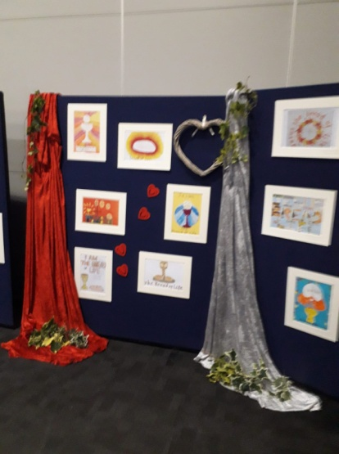
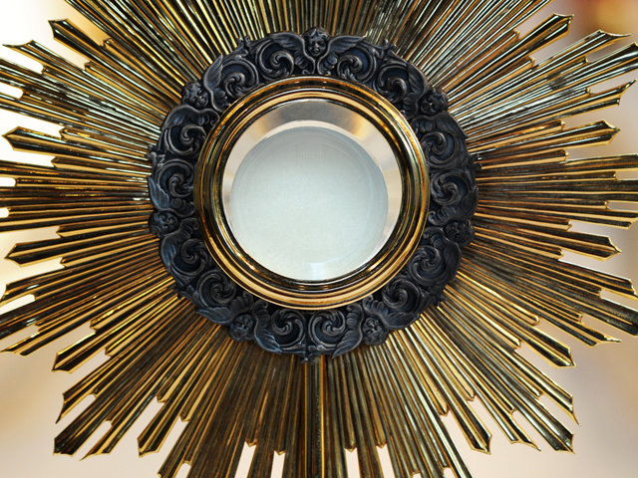
Task:
Create a piece of artwork entitled “The Bread of Life.”
Rules:
- A4 in size (landscape or portrait)
- Any medium (e.g. painting, collage, felt tips, printing etc. etc.)
- Open to Catholic Schools in St Albans, Welwyn Garden City, Borehamwood, Hemel Hempstead, Hatfield and Potters Bar.
- Feel free to use any stimulus you wish, including prayers, monstrance or hymns such as ‘Bread of Life’ or ‘Be still for the presence of the Lord …’
Please send in the artwork to your class teacher by Friday 9th November, labelled on the back with your name and year group.

