The Strange Object (All Work)

Aidan

The Strange Object.

When I went to the back of the dirty Attic I saw a brown and dusty box. There were seven locks on the box, when I touched the box, the seven locks opened on their own. At first I thought it would be a musical instrument but it wasn’t it was a sword, a pirate's sword. It had Diamonds, Sapphires and Ruby sparkling on the handle.
A book laid beside it, it read the story of Captain Phazma. She was a Pirate from the 18th Century, she had been killed by her enemy Captain Finn, as she laid dying she put a curse on the sword “whoever touches this sword will die on the following night. Blood will come out of their eyes and they will die unless the solve my Riddle!!”
The riddle read….. Always running never walking. Often murmuring never talking. Has a bed but never sleeps. Has a mouth but never eats. What is it?
Would I answer it in time….. Do you know the answer!???

THE PORTKEY!! By Sophie

This key belongs to Lady Anne who was brutally murdered on the 9th of September,1990. On the night Lady Anne was killed, a screaming skull was said to pass through the hallway corridors that could be heard for miles.She was murdered in the Orangery which has now rotted into the ground. This key is a time machine to the murder scene of Marwell Manor…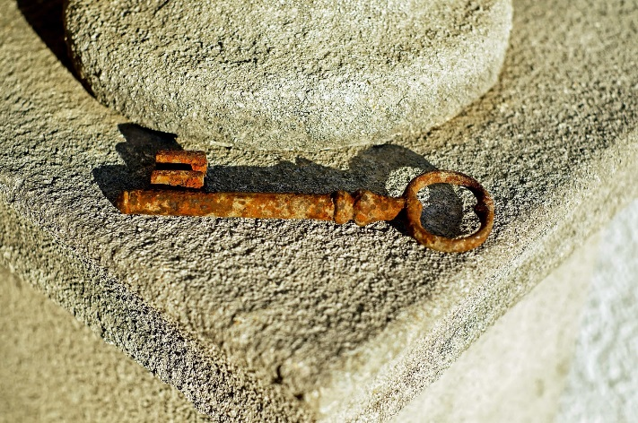
Can you find out the truth of why Kelsey did it. Quick get her story out there before it's too late…

Sofia -

The Strange Object.

I blew the dust off the dust covered box. It was red and looked very old. I placed my hands on it and was horrified but wildly excited to open it. As I opened the box I saw a dirty white envelope. Slowly, I reached for the envelope. Just as I was about to open it I felt something hard and it felt key shaped. Opening the envelope I took a moment to pause and catch a breath and get myself together.

Inside the envelope was a shiny key. It didn't look like an ordinary shaped key. Instead it was shaped like an S. With it came a letter. It said ‘Beware don't keep this key throw it away with this note or you will regret it.’

Name...Benjamin

The Strange Object.
I look around the box and it looks old from what I see. It looks about 76 years old. I can’t be sure but I think it had a sticker . It was very dusty. So I wiped off the heaps off the grey dust. So I read it and gasped. It read King Arthur's sword.I opened it up to find inside a
Sword made of the finest iron.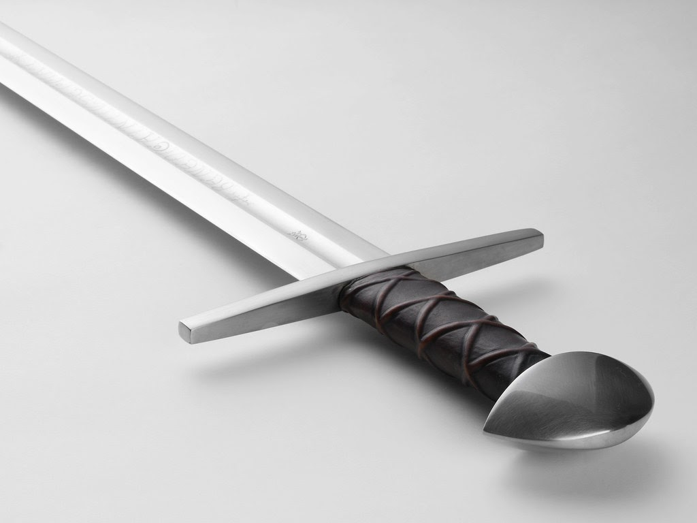
There was something inscribed on the blade, ‘The owner of this sword is unbeatable. And they should use their power to protect my kingdom.’ There was also a piece of parchment saying ‘God gave me this sword so I could become his general. Now it’s your turn.’

Name...JAMES

The Strange Object.
It was a casual saturday morning, the wind blowing, the flowers blooming, me and my cousin, ,Anthony, were at our grandad’s house., since our parents were talking downstairs we were left upstairs, in the bedroom, even though we were together, we were VERY VERY bored. “T, that's it, i’m going to the loft,” Anthony said.
,””But you remember what Mum said, no up in the loft,”
“I Just can't take it anymore, they expect us kids to stay down here, rubbish, child abuse.,”
“Alright, but only for ten minutes, we have to go soon,”I told him. , Sso we hopped up the ladder and walked around, we just really touched things, you know ,what kids do, then we found a peculiar ornate box with some ancient writing on it, “Wwhat does it say?”, Anthony asked.
, “I dunno, it's not in english,”
“Let's open it!” he said.
, “Wait!”
“Wwhat,”replied Aanthony.
,”Nn-never mind”
As he opened the box, lLight flooded the room, and, BOOM!!!! we woke up with an even peculiar- looking egg, neither of us said a word,then the egg did the strangest thing, it seemed to be glowing up with orange light. , I touched it.,”OW!,”
“what! did it sting you?”
“No its hot,”
Suddenly it dissolved and lava spurted all over the room,
“What the-?” Replacing the egg was a baby dragon.”A note!”
Anthony started to read, it said,
Greetings travellers, I expect since you have now found this note you have seen my baby dragon, Malten, he is quite feisty and needs training to fight snow guard, whenever you find this note, he is now yours, congrats! Now i've got to go , strictly come dual with yourself, see ya!

Name:Cristina

The Strange Object.
One Day I went to visit my Auntie’s new house and it was very big.When I got inside it felt like it wasn’t safe for me to be in here.I went upstairs I saw an attic so I decided to go up in the people who used to live here must of forgotten to bring some stuff with them because there were lots of boxes and suitcases. As I looked around I found a wooden box when I opened it there was a black briefcase, I opened it inside there was money and a letter that looked really old and it was stained with which looked like mud.It had writing on it i couldn't read it because of all the stains.I wonder who used to live here,were they a friend of my Aunties and did they know one of my family members?

Name… Josh

The Key
As I walk out of the house I trip on the rickety pavement, smashing my head on the concrete below. I fall into deep, deep, deep dreamy sleep.

As I stood up, I was lying on a busy city road and right in front of me was an old earth caused, crumbled mansion. Shockingly, it was made out of wood and all the windows looked like a bullet had passed through them.
Then, to my surprise, Mum asked me if I like ‘our new home’. As she said this, horror swallowed up my soul as I shouted at her saying that I couldn't live there because it was a pigsty. Calmly she told me that if I really don’t like it then we could think about other options but I had to have a look around first. I agreed, and so we walked into ‘our new home’. Mum was showing me around the house when I asked if I could go see if there was anything that was left behind from the last people who visited in the attic. She agreed so off I went.
The attic was humongous. Even though the lights were off, I could still tell as it was very echoey. I felt around and found the light switch. I turned on the lights to see nothing but an old torn box. I thought that there would have been more exciting things but this would have to do.
When I opened the box I found a Key along with a note.
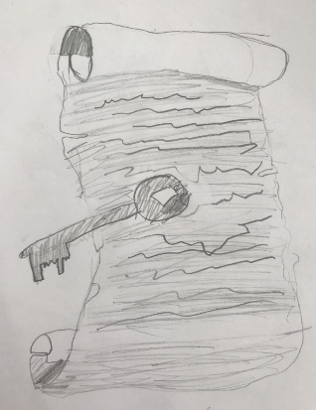
The note was written by a man named CountOlaf , the creator of this very key.
The note read:
Ahh, I see that you have found Count. Olaf’s mysterious key. You may be wondering,who is this mysterious
Count. Olaf and what am I doing with his special key. That key holds great
Treasures. It holds all of my fortune and belongings. To find all of my fortune you must, on a full moon, open up the porthole window above your head and let the moonlight shine on the key and then run a metre away from the key or else you will perish to the weight of my coinage. The money will be yours. Spend it wisely. Good luck.
Yours Truly,
Count Olaf

That very full moon I did what he wrote and sure enough the money came raining down. I went and told mum and then we started to swim in the gold. Then, that very next week we were looking around houses in the calm, tranquil countryside.So maybe I was wrong about the house being so bad because that key didn't just unlock money, it unlocked mine Mum’s eternal happiness…

By Roisin

The Strange Object.
It was dark when I entered the tiny attic space.There was a very moldy smell that filled the air, a smell that would suggest that no one had been up there for years. In the corner there was a covered table.The cloth was old and dusty but had a mysterioues look about it. I went over to investigate.I found a small space that was covered in spider webs. ,Lluckily, earlier on the table, I found a wooden stick which I used to clear the webs away. Under the cob webs I found a suspicious looking box.

Inside the mysterious box,there was an unusual looking object wrapped in a silk cloth. As I unwrapped the cloth I unveiled a beautiful,shiny book that looked as if it was brand new. The front cover was outlined in gold flowers and a picture of a bewitching mermaid. Her eyes were the colour of the deep blue sea and they looked like they were telling a story.On the top right corner there was a picture of a key. The key was silver and had an emblem of a green emerald in the middle… it was the most beautiful key I had ever seen. On the back cover of the book,there was a delightful picture of a tropical island, that was surrounded by a gorgeous clear blue ocean and tropical trees and plants.There was also a small blurb with the words:; adventurous, mysteries, tropical, exciting, energetic, fearless, dangerous,incredible and once in a lifetime…

Name...Caidan

The Strange Object.

This object contains something very special. Legend says, whoever can find the hidden amulet has the power to do anything. With such power comes big responsibilities that should not be let into the wrong hands. If it does, the world will be in big trouble.
If you get this ,destroy it. I should've done it myself a long time ago.

Name… Sophie
The Strange Object.

The lock of hair

The note read…
This lock of hair belonged to a rich American baby who was kidnapped. When the baby was 10, the kidnappers made her their slave. One night she crept away out into the wild and the next morning the kidnappers couldn’t find her. Later, the kidnappers decided to search for her but couldn't find her. Then, several years later a famous jungle explorer headed out into the jungle and saw a girl with a group of monkeys. He went back to the palace where her mother and father were praying for her and claimed to have seen the girl but when he took them to the jungle, there was nothing there but a lock of hair on the floor. They did DNA results and said it was the girl's lock of hair and there was some monkey but was never found.

By Emily

The Strange Object

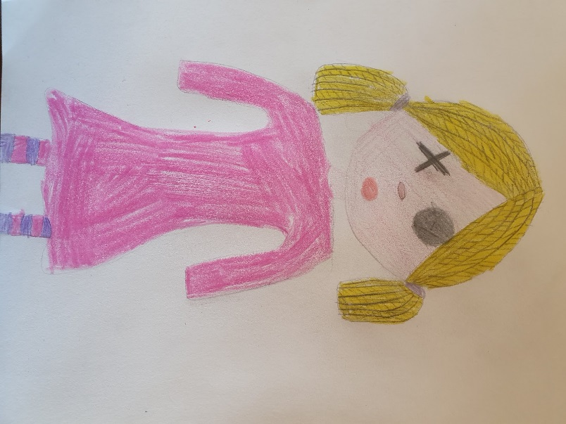

This doll was made by Amy, a servant from the Victorian age. She made it because she missed her family in Greece and she was feeling very lonely.
She caught a serious illness that meant she couldn’t work and she was worried that she would get into trouble. Luckily she was from a magic family and that meant that she could transfer her illness to the doll. She found a box big enough to fit her doll and hid it in the attic under a sheet so no one would find it.

Molly

The Strange Object.
A gold finger

This is the finger of a young American girl. Her name was Gwendoline Lacey and she lived in this old house. Gwendoline was the daughter of a very rich man who liked to spoil her. She was extremely rude and bad mannered and liked her own way. Rumour has it that she was turned to gold one night after being exceptionally spiteful. This is all that is left of her. Some people say that they have seen her finger roaming the house on the anniversary of when she turned to gold.

Name...Teddy

The Strange Object.

The Trophy

In 1942 I evacuated into a house in the countryside. I was moved into a house with a man called Carl. He was a nice man and loved football. He always took me to matches. He also has older relatives who played football and we’d play it in his back garden, he showed me lots of tricks but when he didn't play football he played scrabble.

Then one day, Carl asked me to put the christmas decorations up in the loft. So that’s what I did, I’d never been up there before, I wasn’t scared though. I climbed the ladder to see about a hundred football trophies and lot’s of scrabble boards too. But the thing that stood out the most was a diamond football trophy. Iit had a note on it saying Diamond cup given to Carl. I asked Carl if I could put it in my room and he didn’t seem to mind.

But over many nights the wall the trophy was next to started to crack and as more days passed it got worse. Until one day I had to tell Carl so as I explained it everything started to fall and crumble and then…

Name...Joe

The Strange Object.

I moved into a house that hadn’t been lived in for years, there was ivy all over the exterior. When I was searching for my bedroom I saw some stairs leading up to the attic.I went up the old creaky stairs, I saw lots of boxes but one said: ‘ Do not touch’ I opened the box even though I wasn’t supposed to,there was a charm and a note.

The note said:
‘Whoever opens the box beware of this charm, it is bad luck, people have died and they have been wearing this charm. It has supernatural powers that are deadly. When I moved in,I saw a man dead on the floor. I called the police. They didn’t know what happened to him, when the body was taken away the charm was on his neck. I saw it flashing drawing me in to take it but I didn’t. However, it suddenly appeared back in the house two days later. So I put the charm somewhere no one could find it. Ever since It has been in that box kept away hidden so nobody would get hurt,so just to be clear, keep the charm in the box!!
from Jayden Brown.’

Name...Noah

The Strange Object.

It was the day that we were to move from our home in the city to a house in the country. We didn’t know much about it, only that it was a mansion, rather than a house. We were very excited.

We had arrived after four long hours of driving. I glanced at my watch and it read eleven PM. We were all quite sleepy due to the late hour so we took ourselves to our separate rooms.

The next day, we went exploring, . I was weirdly drawn to the attic and once in the misty, cobweb streaming loft, I discovered a loose floorboard. I prised it open carefully and to my surprise, I found a box with a note and a lumpy, crooked stick.

This is what the note said:;

‘My name is John Scarlett and I am an old necromancer. I leave this strange instrument in the possession of whomever may find it. I use this priceless object, you may call it a wand, to do my business. I have used it throughout my life to do dark magic and you will be able to do just that. However, you will need one thing….Practice!

Here are a few beginner spells to start you off;

Aloft Elavor
This spell is used so you can walk on the air.

Alohamora
This is a charm and is used to unlock doors.

Reparo
This spell should fix things.

Lumos
This will light up the tip of the wand and show the way.’

Name… Natalie -

The Strange Object.

Christmas 1866

This is my doll, Angelina, thank you Mama. I will treasure her forever and will make her like myself: her blue eyes will become brown, she will wear the same dress as me and her blonde locks will be hidden in my own brown hair. If she is hurt, I will then heal her, if she is lost, I will search for her without end and when we share our nightmares, we will comfort each other. My dear Angelina is the best christmas present that has ever been, henceforth I thank you infinitely.
Love Maisie, aged 5 years and 9 months. Xxx

