Coronavirus: mental health and wellbeing resources
Helpful links

- Resources for anxiety, stress and Covid-19 - Safe Hands Thinking Minds
Some resources to support children and adults around anxiety, worry, stress, and fears; including specific Covid-19.
http://www.safehandsthinkingminds.co.uk/covid-anxiety-stress-resources-links/

- How to keep mentally healthy during uncertain times - Action for Happiness
These ideas and examples can help you find ways to look after your wellbeing during the coronavirus outbreak.
https://www.actionforhappiness.org/news/how-to-keep-mentally-healthy-during-uncertain-times

- 5 tips for staying mentally well - Dr Pooky Knightsbridge
A video by Dr Pooky Kinightsbridge where she discusses the various ways you can look after your mental health at this time.
https://www.youtube.com/watch?v=8GmQijmUrkk&feature=youtu.be

- Protecting your mental health - Carers UK
These tips are designed to help both you and those you care for look after yourselves and protect your mental wellbeing.
https://www.carersuk.org/help-and-advice/coronavirus-covid-19/coronavirus-mental-wellbeing

- Supporting children who may be especially vulnerable - Place2Be
Two Principal Educational Psychologists suggest some ways to support children who may be especially vulnerable at this time.
https://www.place2be.org.uk/about-us/news-and-blogs/2020/march/coronavirus-supporting-children-who-may-be-especially-vulnerable/

- COVIBOOK – Mindheart
This illustrated story and workbook is available in 25 different languages and can be printed out for children to draw on. The story anticipates the emotional world of children as they experience
coronavirus. It has been created for children age 2-7 but would be appropriate for children with SEND.
https://www.mindheart.co/descargables

- Coronavirus social story - Carol Gray
This ‘social story’ has been written to help communicate coronavirus to autistic children, presenting the information in a literal way.
https://carolgraysocialstories.com/wp-content/uploads/2020/03/Pandemics-and-the-Coronavirus.pdf

- Easy read information on Covid-19 – Mencap
Mencap have produced an easy read guide to coronavirus which is accessible for people with a learning disability to understand and read.
https://www.mencap.org.uk/sites/default/files/2020-03/Info%20about%20covid19%2026th%20March.pdf

- Tips for coping with OCD during the coronavirus pandemic – YoungMinds
A blog post about how a young person with OCD has experienced coronavirus and some tips on how to cope.
https://youngminds.org.uk/blog/tips-for-coping-with-ocd-during-the-coronavirus-pandemic/

- Tips for coping - OCD Action
OCD Action has put together some helpful tips for those struggling during this particularly challenging time.
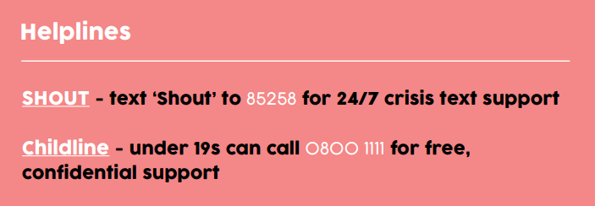
https://ocdaction.org.uk/articles/covid-19

