St Adrian’s Catholic Primary School
Head Teacher: Dominic Bedford
Watling View, St Albans, AL1 2PB
Tel: 01727 852687 Fax: 01727 850822
E-mail: head@stadrians.herts.sch.uk
REF: SAD 433 VA 30 RC N

St Adrian’s Catholic Primary School, St Albans
Admissions to Nursery Policy and Criteria – 2020/21

St. Adrian’s Catholic Primary School was founded by the Catholic Church to provide education for children of Catholic families. The school is conducted by its governing body as part of the Catholic Church in accordance with its trust deed and instrument of government and seeks at all times to be a witness to Our Lord Jesus Christ.

Whenever there are more applications than places available, priority will always be given to Catholic applicants in accordance with the oversubscription criteria listed below. In this policy, ‘applicant’ refers to you, the parent applying for a place, and ‘candidate’ refers to the child for whom an application is made.

As a Catholic school, we aim to provide a Catholic education for all our pupils. At a Catholic school, Catholic doctrine and practice permeate every aspect of the school’s activity. It is essential that the Catholic character of the school’s education is fully supported by all families in the school. Applicants are expected to support the aims and ethos of the school.

The governing body has responsibility for admissions to this school and has a Published Admissions Number (PAN) of 26 pupils to the Nursery class in the school year which begins in September 2020. Applications are invited from families whose child has attained three years of age between 1st September 2019 and 31st August 2020. There will be a single in-take in September 2020.

However, it is possible that existing Nursery parents may choose to delay entry for their child into Reception if their child is born between April 1st 2016 and August 31st 2016. Provided that parents have informed the Governing Body in writing of this intention by March 31st 2021, their child’s Nursery place will be secured and the available Nursery places will be reduced accordingly.

Application Policy & Procedures
Applicants must complete an Early Years Application form for St Adrian’s Catholic School and Nursery and a governors’ Supplementary Information Form (SIF) available from the school office and school website. The information provided is used by governors to apply admission criteria in the event of oversubscription.
. The SIF and Early Years Application Form should be completed in full and returned to the Head Teacher at the school by post or by hand by the published closing date. For a Catholic child a baptismal certificate is required – without this the child will be considered to be non-Catholic.

Continuing Interest
The school maintains a ‘continuing interest’ list for unsuccessful applicants who wish to be considered for a place should one become available in the future. Those on the list will be contacted termly to confirm if they wish to remain on the list. When a place becomes available it will be offered in accordance with the criteria set out in the admission policy in force at the time the admission is considered.

Parents of prospective pupils may visit the school by appointment before making their application.

If there are more than 26 applicants, the Governors will administer the policy using the criteria detailed below. By agreement, and in co-operation with the Local Authority, the Governors will apply their admissions policy criteria to all applications equally in accordance with the ranking system.
Oversubscription Criteria

The following priorities for admission to St Adrian’s School will be observed:

1. Catholic children looked after (CLA) (or previously looked after) and Catholic children who have been adopted (or subject to a child arrangements order or special guardianship orders) immediately following having been looked after.

2. Baptised Catholic children who will have a baptised sibling at St. Adrian’s on the date of admission, and whose parents provide a Certificate of Catholic Practice.

3. Children who are baptised Catholics, whose parents provide a Certificate of Catholic Practice and reside in the geographical parish of St Bartholomew’s.

4. Children who are baptised Catholics, whose parents provide a Certificate of Catholic Practice and are resident in other parishes and for whom St Adrian’s is their nearest Catholic school.

5. Children who are baptised Catholics, whose parents provide a Certificate of Catholic Practice and live in other parishes

6. Baptised Catholic children who will have a baptised sibling at St. Adrian’s on the date of admission, and whose parent(s) is/are unable to provide a Certificate of Catholic Practice on the date of application.

7. Baptised Catholic children, who do not fit any of criteria 1 – 6

8. Other children looked after (CLA) (or previously looked after), other children who have been adopted (or subject to a child arrangement order or special guardianship orders) immediately following having been looked after

9. Non-Catholic children who will have a sibling at St. Adrian’s on the date of admission.

10. Children of other Christian denominations whose membership is evidenced by a minister of religion.

11. Children of other faiths whose membership is evidenced by a religious leader.

12. Any other applicant.

Where there are more eligible applicants than remaining places within a category, after taking into account the above criteria, places will be allocated to those children living nearest to the school. A ‘straight line’ distance measurement is used in all home to school distance measurements in Hertfordshire as outlined in the ‘Starting Nursery booklet’ which is available on line. Distances are measured using a computerised mapping system to two decimal places. The measurement is taken from the Address Base Premium address point of your child’s house to the address point of the school. Address Base Premium data is a nationally recognised method of identifying the location of schools and individual residences.

Multiple births and in-year siblings
If in applying the oversubscription criteria one of two or more siblings born in the same academic year is allocated a place, the other sibling(s) will normally be allocated a place.

Certificate of Catholic Practice
Applicants applying under criteria 2-5 must submit a Certificate of Catholic Practice (CCP) by the closing date. This certificate should be obtained from the priest at the parish where the family normally worship.
It is the parent’s duty to ensure that the CCP is submitted to the school together with the SIF. The priest will only sign this form if he knows you.

For the purposes of this policy, the definition of a Catholic includes a looked after child who is part of a Catholic family where a Priest has certified that the child would have been baptised or received if it were not for their status as a looked after child (e.g. a looked after child in the process of adoption by a Catholic family).

Pupils with an Education, Health and Care Plan.
The admission of pupils with an Education, Health and Care Plan is dealt with by a completely separate procedure. Details of this separate procedure are set out in the Special Educational Needs Code of Practice.
Under the Education Act 1996, the governors are obliged to admit any child with a Statement of Special Educational Needs or an Education, Health and Care Plan where this school is named in the plan.

Late Applications
Applications arriving after the closing date will be dealt with after all initial on-time applications have been processed.

In –Year Admissions
Applications for In-Year admission are also made directly to the school on the school’s Early Years Application Form and own supplementary information form. If a place is available and there is no waiting list then the governing body will admit the child. If more applications are received than there are places available then applications will be ranked by the governing body in accordance with the oversubscription criteria. Parents will be offered the opportunity of being placed on a waiting list. This waiting list will be maintained by the governing body in the order of the oversubscription criteria and not in the order in which the applications are received. Names are reviewed at the end of each term. When a place becomes available the governing body will re-rank the list and make an offer.

Fair Access Protocols
The school is committed to taking its fair share of children who are vulnerable and/or hard to place, as set out in locally agreed protocols. Accordingly, outside the normal admissions round the governing body is empowered to give absolute priority to a child where admission is requested under any local protocol that has been agreed by both the Diocese and the governing body for the current school year. The governing body has this power even when admitting the child would mean exceeding the published admission number.
Appeals
There is no right of appeal for Nursery admissions.

Definition Notes:
Catholic means a member of a Church in full communion with the See of Rome. This includes the Eastern Catholic Churches. This will be evidenced by a Certificate of Baptism in a Catholic Church or a Certificate of Reception into full communion with the Catholic Church.
For the purposes of this policy, this includes a Looked After Child in the process of adoption and living in a Catholic family where a letter from a Priest demonstrates that the child would have been baptised were it not for his/her status as a Looked After Child. For a child to be treated as a Catholic, evidence of Catholic baptism or reception in the Catholic Church will be required. Those who have difficulty obtaining written evidence of baptism should contact their Parish Priest, who after consulting with the Diocese, will decide how the question of baptism is to be resolved and how written evidence is to be produced in accordance with the laws of the Church.

Certificate of Catholic Practice: means a certificate issued by the family’s parish priest (or the priest in charge of the church where the family practises) in the form laid down by the Bishops’ Conference of England and Wales. It will be issued if the priest is satisfied that at least one Catholic parent or carer has (except when it is impossible to do so) attended Mass on Sundays and holy days of obligation for at least five years. It will also be issued when the practice has been continuous since being received into the Church if that occurred less than five years ago. It is expected that most Certificates will be issued on the basis of attendance. A certificate may also be issued by the priest when attendance is interrupted by exceptional circumstances which excuse from the obligation to attend on that occasion or occasions. Further details of these circumstances can be found in the guidance to priests. http://rcdow.org.uk/education/governors/admissions/

“Children of other Christian Denominations”: means children who belong to other churches and ecclesial communities which, acknowledging God’s revelation in Christ, confess the Lord Jesus Christ as God and Saviour according to the Scriptures, and, in obedience to God’s will and in the power of the Holy Spirit commit themselves: to seek a deepening of their communion with Christ and with one another in the Church which is his body; and to fulfil their mission to proclaim the Gospel by common witness and service in the world to the glory of the One God, Father, Son and Holy Spirit. An ecclesial community which on principle has no creedal statements in its tradition, is included if it manifests faith in Christ as witnessed to in the Scriptures and is committed to working in the spirit of the above.
All members of Churches Together in England and of CYTUN are deemed to be included in the above definition as are all other churches and ecclesial communities that are in membership of local Churches Together Group (by whatever title) on the above basis.

“Children of other faiths” means children who are members of a religious community that does not fall within the definition of ‘other Christian denominations’ and which falls within the definition of a religion for the purposes of charity law. The Charities Act 2011 defines religion to include:
- A religion which involves belief in more than one God and
- A religion which does not involve belief in a God
Case law has identified certain characteristics which describe the meaning of religion for the purposes of charity law, which are characterised by a belief in a Supreme Being and an expression of belief in that Supreme Being through worship.

‘Family’ includes the Catholic or Catholics who have legal responsibility for the child.

Looked After Child (CLA): A “looked after child” has the same meaning as in Section 22 of the Children’s Act 1989, and means any child in the care of the Local Authority or provided with accommodation by them (e.g. children with foster parents).

Adopted An adopted child is a child who has been formally adopted, having previously been in care and whose parent / guardian can give proof of this.

Special Guardianship Order A special guardianship order is an order under the terms of the Children Act 1989 s 14A which defines it as an order appointing one or more individuals to be a child’s special guardian(s).

Child Arrangements Order A Child Arrangement order is an order under the terms of the Children Act 1989 s.8 setting the arrangements to be made as to the person with whom the child is to live. Children ‘looked after’ immediately before the order is made qualify in this category.

Parent means the adult or adults with legal responsibility for the child.

Siblings A sibling is defined as: the sister, brother, half brother or sister, adopted brother or sister, child of the parent/carer or partner or a child looked after or previously looked after* and in every case living permanently** in a placement within the home as part of the family household from Monday to Friday at the time of this application. For a sibling relationship to exist the older child must be on the roll of the school at the time the younger child starts.

*Children previously looked after are those children adopted or with special guardianship order or child arrangements order. This definition was amended following a determination by the OSA in August 2014.
**A sibling link will not be recognised for children living temporarily in the same house, for example a child who usually lives with one parent but has temporarily moved or a looked after child in a respite placement or very short term or bridging foster placement.

Tiebreak: Where two applicants (not including twins or multiple births) meet the criteria at exactly the same point after distance has been considered, the following tie break will be applied: random ballot drawn in the presence of an independent witness.

Residency: is taken to be the child’s permanent address on the closing date for applications for a place as advised by HCC. Families who may be in process of moving house must refer to the additional information in the HCC ‘Starting Nursery’ booklet. Residency is defined as the child’s permanent address i.e. that of the parent(s) or guardians who has/have custody of the child and where the child spends more than 50% of the week.

Home address The address provided must be the child’s current permanent address at the time of application. ‘At the time of application’ means the closing date for applications. “Permanent” means that the child has lived at that address for at least a year and/or the family own the property or have a tenancy agreement for a minimum of 12 months.

Parish Boundaries
For the purpose of this policy the geographical parish boundary for St Bartholomew's Parish (St Albans South) is shown on the attached map.

For all other parishes, the relevant parish priest should be consulted, to confirm for the applicant(s) within which parish, their address is situated.

The application can only be processed using one address. If a child lives at more than one address (for example due to a separation) the address used will be the one which the child lives at for the majority of the time. If a child lives at two addresses equally, the address of the parent/carer that claims Child Benefit/Child Tax Credit will be considered as the child’s main residence.

If a family is not in receipt of Child Benefit/Tax Credit alternative documentation will be requested.

If a child’s residence is in dispute, parents/carers should provide court documentation to evidence the address that should be used for admission allocation purposes.

St Bartholomew’s Parish boundary map
Please note the western boundary line runs along the path of the M1
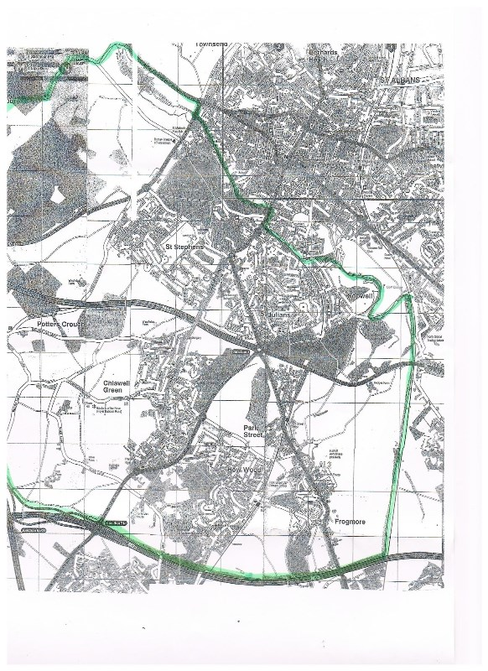
“© Crown copyright and database rights 2014 Ordnance Survey 100019606
You are not permitted to copy, sub-licence, distribute or sell any of this data to third parties in any form.”

