‘I have come so that you may have life to the full……’

Importance of Attendance
The Governors and Staff at St Adrian’s Catholic Primary School recognise that high attendance gives our children the best possible opportunity for learning and reaching their full potential.

Lateness
At St Adrian’s Catholic Primary School, we feel it is essential that children make a positive start to the school day. If children are late they often miss vital instructions and learning and they can also disrupt the class. These are the key timings:
- The school gates are opened at 8.40am and children can come into the playground after that time and enter their classroom from 8.45am.
- All children must be in their classroom, ready to learn, by 8.55 am, which is when the registers are taken. Any child entering school after this time must report to the office and their name will be entered in the late book along with the time of their arrival.
- Registers close at 9.00am. Pupils arriving after this time will be recorded officially late for the morning session unless a satisfactory reason is given, for example a doctor’s appointment.

The Headteacher monitors lateness regularly. The school will make contact with parents or carers where there is a pattern of lateness or several number of lates in a half term.

Legal Responsibility for Attendance
It is the responsibility of the parent or carer to get their children to school and on time. In light of this, parents or carers are required to follow and understand these procedures if their child is ill and unable to come to school:
- Parents/carers must contact the school office by telephone on the first day of absence before 9.30am. Alternatively parents may email the school using the following email address only: admin2@stadrians.herts.sch.uk
- Appropriate codes will be entered in the registers. If you have not reported your child’s absence on each day of absence, the school office will aim to contact you or other adults on your contact list. If this is unsuccessful then a home visit may be made by school staff
- Any missed session will be recorded as unauthorised until a valid reason is obtained, and any further sessions will be given appropriate absence codes. Parents/carers must contact the school on each continuing day of absence unless/until they inform the school of their child's return date.

Teachers and office staff will be available to discuss reasons for absence with children/parents/carers as appropriate. The Headteacher monitors attendance data and termly visits are made by the Educational Welfare Officer to monitor registers. They will contact parents/carers whose child’s absence causes concern to discuss how things can be improved.

Persistent Absentees
A child would be identified as a ‘persistent absentee’ if s/he crosses the thresholds within the current half term. To avoid children falling into this category and to support families, the school will attempt to alert parents if a child is approaching a threshold figure.
The Education (Pupil Registration) (England) Regulations 2006 Section 12 requires schools to inform the local authority of any pupils who are regularly absent from school, have irregular attendance, or have 10 or more consecutive school days absence without the school's permission. As such the Local Authority will be informed of children identified as having persistent absence from St Adrian’s.
The half-termly thresholds by which a child would be identified as a ‘persistent absentee’ are:
- Within the first half of the autumn term it would be 7 sessions (each day is made up of 2 sessions)
- Within the second half term it would be 14 sessions
- Within the third half term it would be 19 sessions
- Within the fourth half term it would be 25 sessions
- Within the fifth half term it would be 31 sessions
- By the end of the school year it would be 38 sessions

Holidays during Term Time
No holidays will be authorised during term time.
It is expected that parents or carers arrange holidays in the school holidays. If holidays are taken in term time parents/carers may be eligible to receive a fixed penalty fine. Holidays should be taken during the school holiday periods and the school's policy is that absence for holidays will not be authorised during term time.

If parents choose to take children out of school for holidays in term time, teachers will not provide additional work for pupils during the given period or reschedule school meetings and events to accommodate them e.g. parent teacher consultations, class meetings etc.

Penalty Notice Fines
Please be aware that the £60 fine is levied for each child in a family on our school registers and to each parent. So, for example three children on holiday would incur a penalty fine of £180 to each parent totalling £360 to the family.

Absence for Exceptional Circumstances
Parents must apply in writing in advance to the Headteacher should they wish to take their child/children out of school for any reason during term time. The Headteacher will only authorise absence during term time in very exceptional circumstances. The expected return date must be specified and adhered to. If authorisation is granted any subsequent delay or absence after this date will be unauthorised. If a child does not return to school 10 days after the expected return date, the school reserves the right to remove that child's name from the school roll. The resulting vacancy will be filled according to the school's normal admission procedures.

Other Unauthorised Absence
A parent/carer/sibling being unwell is not a reason for absence and parents/carers must make arrangements for their children to be brought to school and to be collected. The school will direct parents/carers to external support which may be available and offer help and support as far as practicable if this is a long-term condition. Any such absence will be recorded as unauthorised.

Medical or Dental Appointments
Absence from school due to a medical or dental appointment may be considered as an authorised absence. Parents/carers are encouraged to make medical and dental appointments out of school hours as far as possible. Parents/carers may be requested to provide written confirmation of appointments when they are made and prior to the appointment. Where practical, children are expected to attend school either side of the appointment time.

Consequences of Unauthorised Absence
Where a pupil incurs a certain level of unauthorised absence and there is a level of concern, the case may be referred by the Headteacher to the Educational Welfare Officer who will advise and support parents on the pupil's attendance difficulties and if no improvement is made and/or may use statutory powers under the Education Act, including the issuing of a Penalty Notice, where appropriate. The Local Authority School Attendance Service may also instigate legal proceedings if appropriate.

Child Missing Education
If parents do not provide information about a child’s absence and the school cannot make contact with them within 2 school days, then a child is considered to be a 'Child Missing from Education'. This means the Local Authority has a legal duty to carry out investigations, which will include liaising with Children’s Services, the Police and other agencies, to try to locate missing child/children.

Responsibility for Policy
This Policy is in line with the attendance guidance from the relevant advisory bodies and has been approved by the school's senior leadership team.

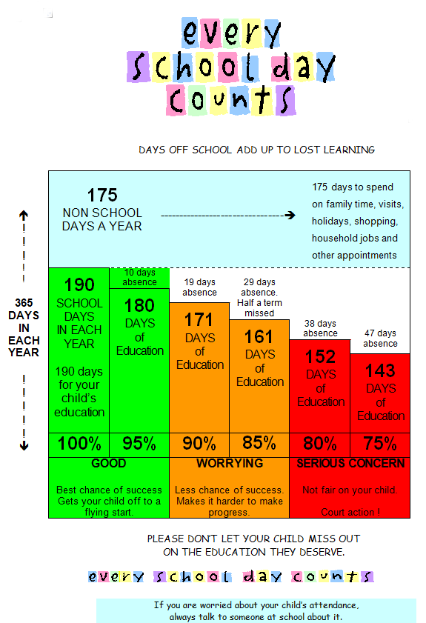

Publication of Policy
This policy will be published on the school website www.stadrians.herts.sch.uk and a copy is available on request from the school office.

C:MyDocuments/Policies/Attendance Policy
June 2018

