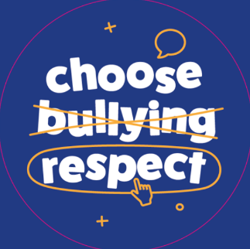
Anti-bullying poster competition
Next week is anti-bullying week. This year’s theme is ‘Choose Respect’. The School Council would like you to design a new anti-bullying poster to inform people about bullying and how at school we ‘Choose Respect’ instead of treating people badly.

Who can submit a poster? | All children from Year 1 to 6
Deadline | Wednesday 14th November
How should I submit my entry? | If created on a computer, please send to the office via email or bring it in on a named USB stick.  If created on paper, please hand it in to your teacher.
What should I include? | It must include a short definition of what bullying is and reflect this year’s theme of ‘Choose Respect’.  Try to include a good balance of images and information. Lots of information can be found at: https://www.anti-bullyingalliance.org.uk/anti-bullying-week
Who will judge the entries? | The School Council will judge the entries on Thursday 15th November.
When will the winner be revealed? | Friday 16th November. There will be one winner from Year 1 and 2, one from year 3 and 4 and one from year 5 and 6.
If you have any further questions, please speak to a member of the School Council or Mr Sallis.
This is activity will be your English homework for the week.

