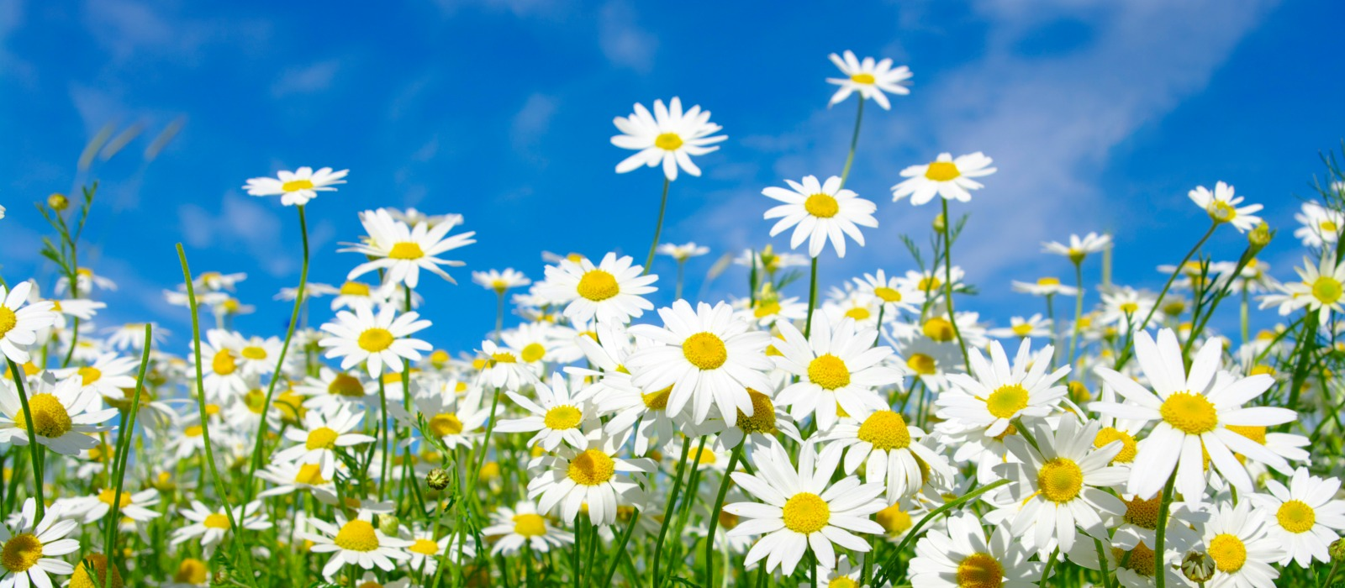

Computing

The focus of our learning this term is:

♦ Creating a web page about e-safety

PE

In PE, we develop our skills through:   
♦ athletics ♦ tag rugby♦Dance♦gymnastics

French

We continue to develop our French skills with Mme Dembeck

Maths

In maths, we further develop our confidence and independence in solving problems with:

♦ Fractions♦ decimals and percentages ♦ Graphs ♦   
♦Word problems

English

Our learning centres on these texts:

♦ **Rhyme, rhythm and beat**: ♦ inspired by Nightmail by W H Auden  
♦**Narrative** ♦ Mystery and suspense (Marwell Manor, Harwell Hall)  
♦ **Instructions, Persuasive**: - Origami Yoda by Tom Angleburger ♦

Religious Education

Our RE learning for the term follows the themes:

♦ Local Church – Mission ♦  
♦ Eucharist - Memorial♦   
♦ Lent/Easter - Sacrifice ♦

Science

Our science learning focuses on:

♦Changing materials♦  
♦ Forces♦

Foundation subjects

♦ Geography – North America – Physical and human features of the USA♦  
♦ History –The Battle of Britain♦  
♦ Art –Making a special container ♦   
♦ DT – Musical instruments ♦

**Mr Creaton – Year 5**

**Spring term**

**2018**

**Curriculum Overview**