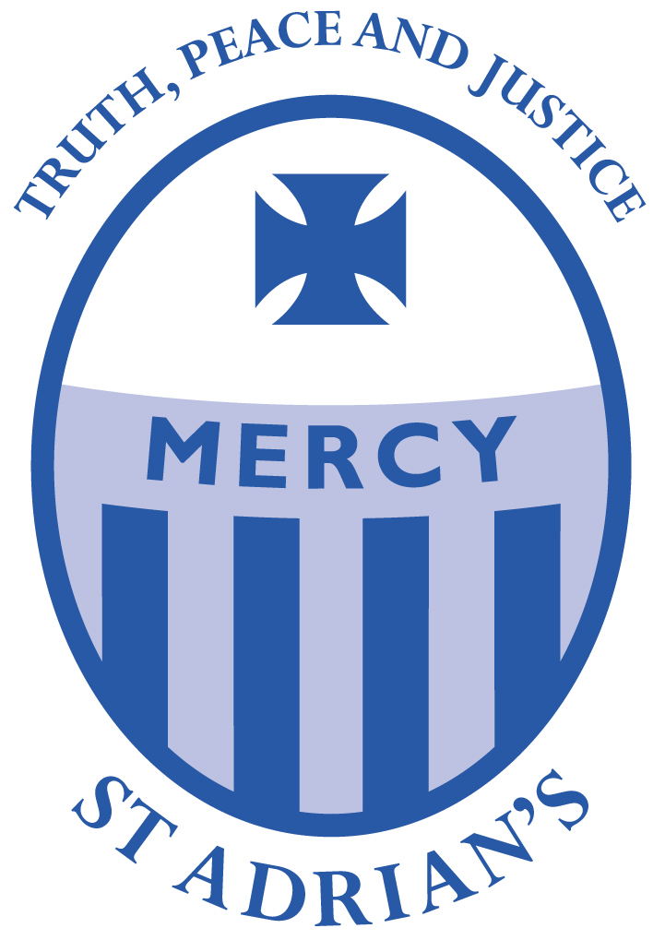
Diocese of Westminster
Catholic Primary Schools
Supplementary Information Form 2018 – 2019



Name and Address of School:
St Adrian’s Catholic Primary School & Nursery, Watling View, St Albans. AL1 2PB

Child’s Details
Child’s surname:
Child’s Christian or other first name:
Home Address: | Date of Birth:
 | Postcode:

Parent/Carer Details
Parent(s)/Carer(s) name:
Address (if different from above):
Telephone number:
Email address
Alternative contact details:
Name:
Address:
Telephone number:
Email address

Details of Religion
Religion of child:  (Please tick) | Catholic | Other Christian (name of denomination e.g Methodist) | Other faith
Catholic Parish you live in:
Church where child was baptised and date of baptism: (baptism certificate required)

Name and position of priest providing Certificate of Catholic Practice or religious leader supplying letter confirming membership of faith community (where appropriate) :
Names of brothers or sisters at this school, who will be in attendance at the date of admission  Is your child ‘looked after’ by the Local Authority, adopted or subject to a child arrangements or special guardianship order having previously been ‘looked after’? (Please circle your response) |  | Name Class or Year Group  YES NO

I confirm that I have read and understood the Admissions Policy and that the information I have provided is correct. I understand that I must notify the school immediately if there is any change to these details and that should any information I have given prove to be inaccurate that the governors may withdraw any offer of a place even if the child has already started school.

Signed……………………………………… Date…..…………………

Please note:
- Where applicable parents can obtain a Certificate of Catholic Practice form from the school or from the Diocese of Westminster website at www.rcdow.org.uk/Education Follow schools/parents/admissions. Applicants from other Christian denominations and other faiths may attach a baptism certificate or a letter confirming membership of the faith community from their minister or religious leader.
- You must complete your local authority’s Common Application Form and return it to the council offices by the closing date. If you do not do this you will not be offered a place.

Checklist:
Have you enclosed? Copy of baptism certificate (where necessary)
Certificate of Catholic Practice Form (where necessary)
Evidence of exceptional need (where appropriate)
Have you completed your local authority’s Common Application form?

